Reserve Certainty Sr. Task Force
Teleconference/Webex
May 01, 2026
9:00 a.m. – 4:00 p.m. EPT

Administration (9:00-9:10)
Lisa Morelli, facilitator, and Amanda Egan, secretary, will welcome participants, make announcements and review of the Anti-trust, Code of Conduct, and Media Participation Guidelines.

CBIR (9:10-12:00)
- Catherine Tyler, Monitoring Analytics, will present an overview of the IMM package and the IMM’s perspective on RCSTF issues.
- Jane Wei, Monitoring Analytics, will present the IMM’s proposed reserve requirements calculation method and results.

Lunch (12:00-1:00)

CBIR Cont. (1:00-3:50)
- Shubhrajit Bhattacharjee, PJM, will present simulation results that illustrate the Day-Ahead Market clearing outcomes of PJM’s proposed reserve market reforms for 2025.
- Emily Barrett, PJM, will provide an overview of the supporting documentation provided on PJM’s proposed package.
- Lisa Morelli will lead a discussion of the CBIR matrix and solicit additions from stakeholders.
- Lisa Morelli will review the poll to be issued following this meeting.

Future Agenda Items (3:50-4:00)
Lisa Morelli will review action items and discuss next steps.
Future Meeting Dates and Materials |  |  | Materials Due  to Secretary | Materials Published
Date | Time | Location |  | Materials Published
May 21, 2026 | 9 am to 4 pm | Teleconference/Webex | May 13, 2026 | May 18, 2026
June 10, 2026 | 9 am to 4 pm | Teleconference/Webex | June 02. 2025 | June 05, 2026
June 25, 2026 | 9 am to 12 pm | Teleconference/Webex | June 17, 2026 | June 22, 2026
Author: Amanda Egan

Antitrust:
You may not discuss any topics that violate, or that might appear to violate, the antitrust laws including but not limited to agreements between or among competitors regarding prices, bid and offer practices, availability of service, product design, terms of sale, division of markets, allocation of customers or any other activity that might unreasonably restrain competition. If any of these items are discussed the chair will re-direct the conversation. If the conversation still persists, parties will be asked to leave the meeting or the meeting will be adjourned.
Code of Conduct:
As a mandatory condition of attendance at today's meeting, attendees agree to adhere to the Code of Conduct as detailed in PJM Manual M-34 section 4.5, including, but not limited to, participants' responsibilities and rules regarding the dissemination of meeting discussion and materials. Expectations for participating in PJM activities are further detailed in the PJM Code of Conduct.
Public Meetings/Media Participation:
Unless otherwise noted, PJM stakeholder meetings are open to the public and to members of the media. Members of the media are asked to announce their attendance at all PJM stakeholder meetings at the beginning of the meeting or at the point they join a meeting already in progress. Members of the Media are reminded that speakers at PJM meetings cannot be quoted without explicit permission from the speaker. PJM Members are reminded that "detailed transcriptional meeting notes" and white board notes from "brainstorming sessions" shall not be disseminated. Stakeholders are also not allowed to create audio, video or online recordings of PJM meetings. PJM may create audio, video or online recordings of stakeholder meetings for internal and training purposes, and your participation at such meetings indicates your consent to the same.
Participant Identification in Webex:
When logging into the Webex desktop client, please enter your real first and last name as well as a valid email address. Be sure to select the “call me” option.
PJM support staff continuously monitors Webex connections during stakeholder meetings. Anonymous users or those using false usernames or emails will be dropped from the teleconference.
Participant Use of Webex Chat:
The use of the Webex chat feature during meetings shall be primarily reserved for administrative and logistical purposes, such as managing a question or comment queue, noting technical difficulties, and meeting support or management purposes. Utilizing Webex chat for any other commentary should be limited to short phrases. Detailed commentary or substantive dialog shall be shared orally by entering the speaker queue.

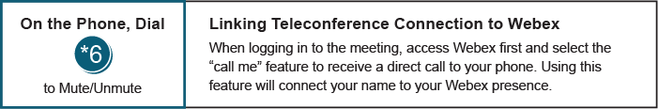

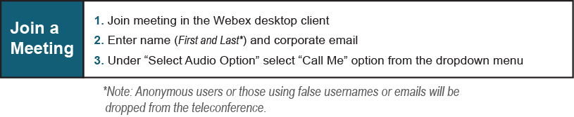
Provide feedback on the progress of this group: Facilitator Feedback Form
Visit learn.pjm.com, an easy-to-understand resource about the power industry and PJM’s role.

