Reactive Power Compensation Task Force
WebEx / Teleconference
November 29, 2022
1:00 p.m. – 4:00 p.m. EPT

Issue Tracking: Reactive Power Compensation https://www.pjm.com/committees-and-groups/task-forces/rpctf

Administration (1:00-1:10)

Danielle Croop and Risa Holland will provide welcome, announcements, introductions, and review of the Antitrust, Code of Conduct, and Public Meetings/Media Participation Guidelines.
Stakeholders will be asked to approve the draft minutes from the October 20, 2022 RPCTF meeting.
Danielle Croop, PJM, will review the Reactive Power Compensation Task Force agenda.
AEP Methodology for Generator Reactive Power Supply Compensation overview (December 3, 2021 RPCTF)

CBIR Process (Proposed Options) (1:10-3:45)
- Danielle Croop, will facilitate a discussion of proposal packages.
- Dr. Joe Bowring, IMM, will review the IMM’s proposal updates (Packages F and H).
- Bruce Grabow, Frank Swigonski and Wade Horigan, CEC, will review CEC’s proposal update. (Package B).
- Glen Boyle, PJM, will review PJM’s proposal updates (Packages E and G).

- Danielle Croop, PJM, will discuss next steps, including stakeholder feedback incorporated in the updated polling questions.
- Darrell Frogg, PJM, will review the illustrative examples of Reactive Capability (D-Curves) and Corresponding Compensation (Packages E and G).
- Bruce Grabow, Frank Swigonski and Wade Horigan, CEC, will provide additional discussion regarding CEC’s and PJM’s proposal.
Future Meeting Dates and Materials |  |  | Materials Due  to Secretary | Materials Published
Date | Time | Location |  | Materials Published
November 29, 2022 | 1:00 p.m. | Webex / Teleconference | November 17, 2022 | November 22, 2022
2023 Meetings | TBD | Webex / Teleconference | TBD | TBD

Author: Risa Holland

Antitrust:
You may not discuss any topics that violate, or that might appear to violate, the antitrust laws including but not limited to agreements between or among competitors regarding prices, bid and offer practices, availability of service, product design, terms of sale, division of markets, allocation of customers or any other activity that might unreasonably restrain competition. If any of these items are discussed the chair will re-direct the conversation. If the conversation still persists, parties will be asked to leave the meeting or the meeting will be adjourned.

Code of Conduct:
As a mandatory condition of attendance at today's meeting, attendees agree to adhere to the PJM Code of Conduct as detailed in PJM Manual M-34 section 4.5, including, but not limited to, participants' responsibilities and rules regarding the dissemination of meeting discussion and materials.

Public Meetings/Media Participation:
Unless otherwise noted, PJM stakeholder meetings are open to the public and to members of the media. Members of the media are asked to announce their attendance at all PJM stakeholder meetings at the beginning of the meeting or at the point they join a meeting already in progress. Members of the Media are reminded that speakers at PJM meetings cannot be quoted without explicit permission from the speaker. PJM Members are reminded that "detailed transcriptional meeting notes" and white board notes from "brainstorming sessions" shall not be disseminated. Stakeholders are also not allowed to create audio, video or online recordings of PJM meetings. PJM may create audio, video or online recordings of stakeholder meetings for internal and training purposes, and your participation at such meetings indicates your consent to the same.
Participant Identification in Webex:
When logging into the Webex desktop client, please enter your real first and last name as well as a valid email address. Be sure to select the “call me” option.
PJM support staff continuously monitors Webex connections during stakeholder meetings. Anonymous users or those using false usernames or emails will be dropped from the teleconference.

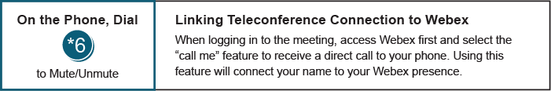

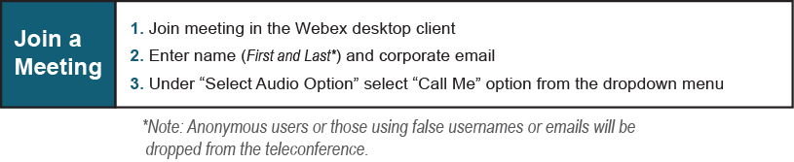

Provide feedback on the progress of this group: Facilitator Feedback Form
Visit learn.pjm.com, an easy-to-understand resource about the power industry and PJM’s role.

