Summer-Only Demand Response Senior Task Force
PJM Conference and Training Center
May 9, 2018
1:00 p.m. – 4:00 p.m. EPT

Administration (1:00 –1:10)
- Welcome, review of Anti-Trust Policy, Code of Conduct, Media Participation Policy and roll call.
- Approve draft minutes from the April 13 SODRSTF meeting.

Education (1:10 – 1:40)
- Ms. Elizabeth Anastasio, PJM, will provide an overview and summary of Load Forecast Error metrics for recent peak periods.
- Mr. John Reynolds, PJM, will provide analysis of peak shaving frequency based on historical zonal summer forecasts.

CBIR Process (1:40 – 4:00)
- Ms. Rebecca Carroll, PJM, will lead a discussion on proposed packages for the Senior Task Force based on the Design Components and Options listed in the SODRSTF Working Matrix.
Break 2:30 – 2:40

Future Agenda Items
Participants will have the opportunity to request the addition of any new item(s) to the agenda of a future meeting.

Future Meeting Dates
June 13, 2018 | 9:30 a.m. – 4:00 p.m. | PJM Conference and Training Center
July 9, 2018 | 9:30 a.m. – 4:00 p.m. | PJM Conference and Training Center
August 15, 2018 | 9:30 a.m. – 4:00 p.m. | PJM Conference and Training Center
September 19, 2018 | 9:30 a.m. – 4:00 p.m. | PJM Conference and Training Center
October 17, 2018 | 9:30 a.m. – 4:00 p.m. | PJM Conference and Training Center
November 19, 2018 | 9:30 a.m. – 4:00 p.m. | PJM Conference and Training Center
December 5, 2018 | 9:30 a.m. – 4:00 p.m. | PJM Conference and Training Center

Antitrust:
You may not discuss any topics that violate, or that might appear to violate, the antitrust laws including but not limited to agreements between or among competitors regarding prices, bid and offer practices, availability of service, product design, terms of sale, division of markets, allocation of customers or any other activity that might unreasonably restrain competition. If any of these items are discussed the chair will re-direct the conversation. If the conversation still persists, parties will be asked to leave the meeting or the meeting will be adjourned.

Code of Conduct:
As a mandatory condition of attendance at today's meeting, attendees agree to adhere to the PJM Code of Conduct as detailed in PJM Manual M-34 section 4.5, including, but not limited to, participants' responsibilities and rules regarding the dissemination of meeting discussion and materials.

Public Meetings/Media Participation:
Unless otherwise noted, PJM stakeholder meetings are open to the public and to members of the media. Members of the media are asked to announce their attendance at all PJM stakeholder meetings at the beginning of the meeting or at the point they join a meeting already in progress. Members of the Media are reminded that speakers at PJM meetings cannot be quoted without explicit permission from the speaker. PJM Members are reminded that "detailed transcriptional meeting notes" and white board notes from "brainstorming sessions" shall not be disseminated. Stakeholders are also not allowed to create audio, video or online recordings of PJM meetings. PJM may create audio, video or online recordings of stakeholder meetings for internal and training purposes, and your participation at such meetings indicates your consent to the same.
Participant Identification in WebEx:
When logging into the WebEx desktop client, please enter your real first and last name as well as a valid email address. Be sure to select the “call me” option.
PJM support staff continuously monitors WebEx connections during stakeholder meetings. Anonymous users or those using false usernames or emails will be dropped from the teleconference.

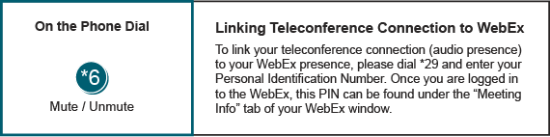

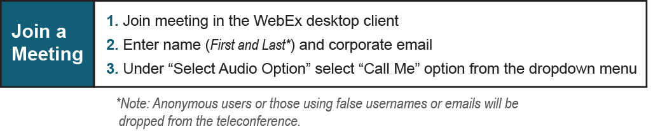

Author: Mike Borradaile
Provide feedback on the progress of this group: Facilitator Feedback Form
Visit learn.pjm.com, an easy-to-understand resource about the power industry and PJM’s role.

