Critical Issue Fast Path - Resource Adequacy
Teleconference
April 19, 2023
9:00 a.m. – 4:00 p.m. EPT

Administration (9:00-9:15)
Dave Anders, facilitator, and Jaclynn Lukach, secretary, will welcome participants, make announcements, and review the Antitrust, Code of Conduct, and Public Meetings/Media Participation Guidelines.
The task force will be asked to approve the Draft Minutes for the RASTF – Stage 1 meeting on March 29, 2023.
Dave Anders will review the CIFP – RA work plan.

CIFP – Resource Adequacy Stage Two Process (9:15-3:50)
Dave Anders will lead a discussion on the CIFP – MOPR Matrix. The following Stakeholders requested the opportunity to provide additional options for consideration.
  - Marc Montalvo (EKPC)
  - Joe Bowring (IMM)
  - Lynn Horning/Steve Lieberman (AMP)
A lunch break will be approximately around Noon

Next Steps (3:50-4:00)
Dave Anders, PJM will discuss next steps.

Future Agenda Items
Accreditation Discussion

Future Meeting Dates and Materials |  |  | Materials Due  to Secretary | Materials Published
Date | Time | Location |  | Materials Published
April 26, 2023 | 1:00 pm – 4:00 pm | PJM Conference & Training Center / WebEx | April 18, 2023 | April 21, 2023
May 17, 2023 | 9:00 am – 4:00 pm | PJM Conference & Training Center / WebEx | May 9, 2023 | May 12, 2023
May 30, 2023 | 9:00 am – 4:00 pm | PJM Conference & Training Center / WebEx | May 19, 2023 | May 25, 2023
June 14, 2023 | 9:00 am – 4:00 pm | PJM Conference & Training Center / WebEx | June 5, 2023 | June 9, 2023

Author: J. Lukach

Antitrust:
You may not discuss any topics that violate, or that might appear to violate, the antitrust laws including but not limited to agreements between or among competitors regarding prices, bid and offer practices, availability of service, product design, terms of sale, division of markets, allocation of customers or any other activity that might unreasonably restrain competition. If any of these items are discussed the chair will re-direct the conversation. If the conversation still persists, parties will be asked to leave the meeting or the meeting will be adjourned.

Code of Conduct:
As a mandatory condition of attendance at today's meeting, attendees agree to adhere to the PJM Code of Conduct as detailed in PJM Manual M-34 section 4.5, including, but not limited to, participants' responsibilities and rules regarding the dissemination of meeting discussion and materials.

Public Meetings/Media Participation:
Unless otherwise noted, PJM stakeholder meetings are open to the public and to members of the media. Members of the media are asked to announce their attendance at all PJM stakeholder meetings at the beginning of the meeting or at the point they join a meeting already in progress. Members of the Media are reminded that speakers at PJM meetings cannot be quoted without explicit permission from the speaker. PJM Members are reminded that "detailed transcriptional meeting notes" and white board notes from "brainstorming sessions" shall not be disseminated. Stakeholders are also not allowed to create audio, video or online recordings of PJM meetings. PJM may create audio, video or online recordings of stakeholder meetings for internal and training purposes, and your participation at such meetings indicates your consent to the same.
Participant Identification in Webex:
When logging into the Webex desktop client, please enter your real first and last name as well as a valid email address. Be sure to select the “call me” option.
PJM support staff continuously monitors Webex connections during stakeholder meetings. Anonymous users or those using false usernames or emails will be dropped from the teleconference.

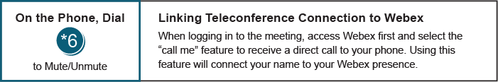
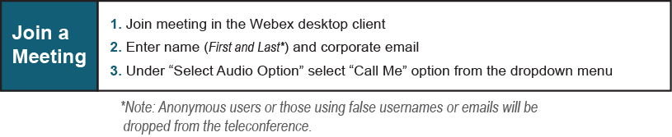
Provide feedback on the progress of this group: Facilitator Feedback Form
Visit learn.pjm.com, an easy-to-understand resource about the power industry and PJM’s role.

