Agenda
Members Committee
Two Hundred-tenth Meeting
WebEx Only Meeting
May 3, 2021
1:00 p.m. – 5:00 p.m. EDT

- Administration (1:00-1:05)
- Announce sector selections of new members since the last meeting and any members
changing sector – David Anders
- Confirm the presence of a quorum of representatives or designated alternates for this
meeting – David Anders
- Antitrust and Code of Conduct announcement – David Anders
- Comments by the President and CEO (1:05-1:30)
Manu Asthana will provide remarks to reflect on his first year with PJM and his vision to the future.
- Recognition of Board Members Ake Almgren and Neel Foster (1:30-1:45)
Manu Asthana will provide remarks in recognition of the retirement of PJM Board Members Ake Almgren and Neel Foster.
- PJM Board of Managers Nominating Committee (NC) (1:45-2:00)
Charlie Robinson will review the activities of the NC. The Members Committee will be asked to elect members of the Board of Managers.
- Year in Review (2:00-3:00)
Susan Buehler will facilitate a panel discussion reviewing operations, markets, planning, and market monitoring & surveillance perspectives of the past year. Panelists will include Michael Bryson, Stu Bresler, Kenneth Seiler, and Joseph Bowring.
- Consent Agenda (3:00-3:05)
- Approve draft minutes of the April 21, 2021 meeting.

- Reports (3:05-3:45)
- Report on system operations – Paul McGlynn
- Report on market operations and interregional coordination – Timothy Horger
- Report on PJM’s response to COVID-19 – Scott Heffentrager
- MC Vice Chair Report (3:45-4:00)
- Provide an update on Members Committee Annual Plan – Steve Lieberman
- Discuss the plans for the upcoming July 26, 2021 Liaison Committee meeting with the PJM Board of Managers – Steve Lieberman
- Future Agenda Items (4:00)
- Future Meetings

June 23, 2021  June 30, 2021 | 1:15 p.m.  2:00 p.m. | WebEx  WebEx
July 28, 2021 | 1:15 p.m. | WebEx
September 29, 2021 | 1:15 p.m. | WebEx
October 20, 2021 | 1:15 p.m. | WebEx
November 17, 2021 | 1:15 p.m. | WebEx
December 15, 2021 | 1:15 p.m. | WebEx

Author: D. Anders
Antitrust:
You may not discuss any topics that violate, or that might appear to violate, the antitrust laws including but not limited to agreements between or among competitors regarding prices, bid and offer practices, availability of service, product design, terms of sale, division of markets, allocation of customers or any other activity that might unreasonably restrain competition. If any of these items are discussed the chair will re-direct the conversation. If the conversation still persists, parties will be asked to leave the meeting or the meeting will be adjourned.
Code of Conduct:
As a mandatory condition of attendance at today's meeting, attendees agree to adhere to the PJM Code of Conduct as detailed in PJM Manual M-34 section 4.5, including, but not limited to, participants' responsibilities and rules regarding the dissemination of meeting discussion and materials.
Public Meetings/Media Participation:
Unless otherwise noted, PJM stakeholder meetings are open to the public and to members of the media. Members of the media are asked to announce their attendance at all PJM stakeholder meetings at the beginning of the meeting or at the point they join a meeting already in progress. Members of the Media are reminded that speakers at PJM meetings cannot be quoted without explicit permission from the speaker. PJM Members are reminded that "detailed transcriptional meeting notes" and white board notes from "brainstorming sessions" shall not be disseminated. Stakeholders are also not allowed to create audio, video or online recordings of PJM meetings. PJM may create audio, video or online recordings of stakeholder meetings for internal and training purposes, and your participation at such meetings indicates your consent to the same.
Participant Identification in WebEx:
When logging into the WebEx desktop client, please enter your real first and last name as well as a valid email address. Be sure to select the “call me” option. PJM support staff continuously monitors WebEx connections during stakeholder meetings. Anonymous users or those using false usernames or emails will be dropped from the teleconference.

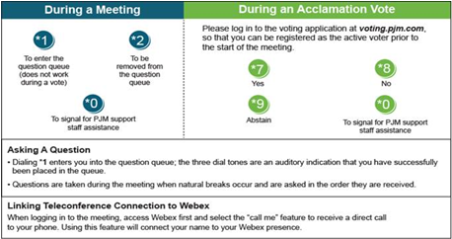

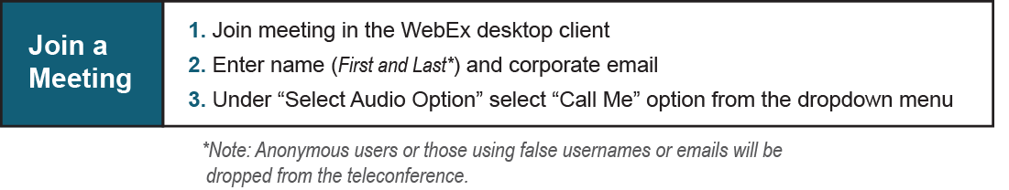
Provide feedback on the progress of this group: Facilitator Feedback Form
Visit learn.pjm.com, an easy-to-understand resource about the power industry and PJM’s role.

