Market Implementation Committee
PJM Conference & Training Center, Audubon, PA
August 9, 2017
9:00 a.m. – 4:00 p.m. EPT

Administration (9:00-9:15)
Ms. Chantal Hendrzak, PJM, and Ms. Christina Stotesbury, PJM, will provide announcements and review the Antitrust, Code of Conduct, and Public Meetings/Media Participation Guidelines.

The committee will be asked to approve draft minutes from the July 12, 2017 Market Implementation Committee meeting.

Ms. Christina Stotesbury, PJM, will review the active MIC issues on Issue Tracking. The Committee will be asked if there are any objections to closing out the following MIC issues that are On-Hold.
Energy Scheduling
Financial Transmission Rights Forfeiture Rule Review
Spot-in Transmission Service for Energy Imports from NYISO

Mr. Hal Loomis, PJM, will inform the committee of a survey poll to be taken after the August 31 Credit Subcommittee meeting to ask members if they wish PJM to proceed with an analysis a stakeholder proposed to change the INC/DEC credit requirement.

Endorsements/Approvals (9:15-11:00)
- Manual 11 Revisions for Intraday Offers (9:15-9:45)
- Ms. Lisa Morelli, PJM, will review conforming revisions to Manual 11: Energy & Ancillary Services, associated with the implementation of Intraday Offers. The committee will be asked to endorse the manual revisions.
- Monitoring Analytics will present concerns related to the conforming Manual 11 revisions.

- Governing Document Revisions for PJM-MISO CTS (9:45-10:00)
- Mr. Michael Olaleye, PJM, will review conforming revisions to Manual 11: Energy & Ancillary Services, associated with Coordinated Transaction Scheduling. The committee will be asked to endorse the manual revisions.
- Mr. Bhushan Dhuri, PJM, will review revisions to the Regional Transmission and Energy Scheduling Practices document. The committee will be asked to endorse the revisions.

- Governing Document Revisions to the Limitation on Claims (10:00-10:15)
Mr. Steve Shparber, PJM, will review updated revisions to the Tariff and Operating Agreement related to the Limitation on Claims that were approved at the July MIC. The committee will be asked to endorse the governing document revisions.

- Transmission Penalty Factors – Problem Statement and Issue Charge (10:15-10:30)
Dr. Joe Bowring, Monitoring Analytics, will review a problem statement and issue charge associated with Transmission Penalty Factors. The committee will be asked to approve the issue.

- Market Path/Interface Pricing Point Alignment – Problem Statement and Issue Charge (10:30-10:45)
Dr. Joe Bowring, Monitoring Analytics, will review a problem statement and issue charge associated with Market Path/Interface Pricing Point Alignment. The committee will be asked to approve the issue.

Annual Revenue Requirements for new Black Start Units – Phase 2 (10:45-11:00)
Mr. Tom Hauske, PJM, will review PJM’s position and the single proposed package to address Minimum Tank Suction Levels (MTSL) as part of Phase 2 for the Annual Revenue Requirements for new Black Start units. The Committee agreed to consider the July update on this issue a first read of the proposed solution and will be asked to endorse solution option A.

Break (11:00-11:15)

First Readings (11:15-12:15)
- Manual 6 Revisions for FTR Forfeiture revisions (11:15-11:30)
Mr. Brian Chmielewski, PJM, will present a first read of Manual 6: Financial Transmission Rights revisions associated with FTR Forfeitures. The committee will be asked to endorse the revisions at the September MIC meeting.

- Manual 11 Revisions for Order 831 and Energy Offer Verification (11:30-12:00)
- Mr. Rami Dirani, PJM, will present a first read of Manual 11: Energy and Ancillary Services Market Operations revisions associated with the offer verification process for the implementation of Order 831: Energy Offer Verification. The committee will be asked to endorse the revisions at the September MIC meeting.
- Monitoring Analytics will present concerns related to the Energy Offer Verification Manual 11 revisions.

- Manual 28 Revisions for Intraday Offers (12:00-12:15)
Mr. Ray Fernandez, PJM, will present a first read of Manual 28: Operating Agreement Accounting revisions associated with the implementation of Intraday Offers. The committee will be asked to endorse the revisions at the September MIC meeting.

Lunch (12:15-1:00)

Additional Updates (1:00-2:00)
- 2017 Stakeholder Satisfaction Survey (1:00-1:10)
Ms. Janell Fabiano, PJM, will provide an announcement on the 2017 Stakeholder Satisfaction Survey.

- Fuel Cost Policy Annual Review Update (1:10-1:30)
- Mr. Jeff Schmitt, PJM, will provide an update on the Fuel Cost Policy Annual Review period.
- Dr. Joseph Bowring, Monitoring Analytics, will provide an update on Fuel Cost Policies.
- Order 825: Shortage Pricing Update (1:30-1:45)
Ms. Lisa Morelli, PJM, will provide an update on the shortage pricing data request and review the change to shorten the Real Time Security Constrained Economic Dispatch (SCED) look-ahead interval to 10 minutes.

- Net Energy Injections Quarterly Report (1:45-2:00)
Ms. Jennifer Warner-Freeman, PJM, will review the second quarter 2017 Net Energy Injections report.

Informational Section
Credit Subcommittee (CS)
Meeting materials will be posted to the CS website.

Demand Response Subcommittee (DRS)
Meeting materials will be posted to the DRS web site.

Intermittent Resources Subcommittee (IRS)
Meeting materials will be posted to the IRS web site.

Inter-Regional Coordination Activity
Mr. Tim Horger, PJM, will be available to answer questions on Inter-Regional Coordination efforts. Materials are posted as informational only.

Market Settlements Subcommittee (MSS)
Meeting materials are posted to the MSS web site.

Report on Market Operations
The Report on Market Operations will be reviewed during the MC Webinar.

Future Meeting Dates
September 13, 2017 | 9:00 a.m. | PJM Interconnection – Conference & Training Center
October 11, 2017 | 9:00 a.m. | PJM Interconnection – Conference & Training Center
November 8, 2017 | 9:00 a.m. | PJM Interconnection – Conference & Training Center
December 13, 2017 | 9:00 a.m. | PJM Interconnection – Conference & Training Center

Author: Christina Stotesbury

Antitrust:
You may not discuss any topics that violate, or that might appear to violate, the antitrust laws including but not limited to agreements between or among competitors regarding prices, bid and offer practices, availability of service, product design, terms of sale, division of markets, allocation of customers or any other activity that might unreasonably restrain competition. If any of these items are discussed the chair will re-direct the conversation. If the conversation still persists, parties will be asked to leave the meeting or the meeting will be adjourned.

Code of Conduct:
As a mandatory condition of attendance at today's meeting, attendees agree to adhere to the PJM Code of Conduct as detailed in PJM Manual 34 Section 4.5, including, but not limited to, participants' responsibilities and rules regarding the dissemination of meeting discussion and materials.

Public Meetings/Media Participation:
Unless otherwise noted, PJM stakeholder meetings are open to the public and to members of the media. Members of the media are asked to announce their attendance at all PJM stakeholder meetings at the beginning of the meeting or at the point they join a meeting already in progress. Members of the Media are reminded that speakers at PJM meetings cannot be quoted without explicit permission from the speaker. PJM Members are reminded that "detailed transcriptional meeting notes" and white board notes from "brainstorming sessions" shall not be disseminated. Stakeholders are also not allowed to create audio, video or online recordings of PJM meetings.

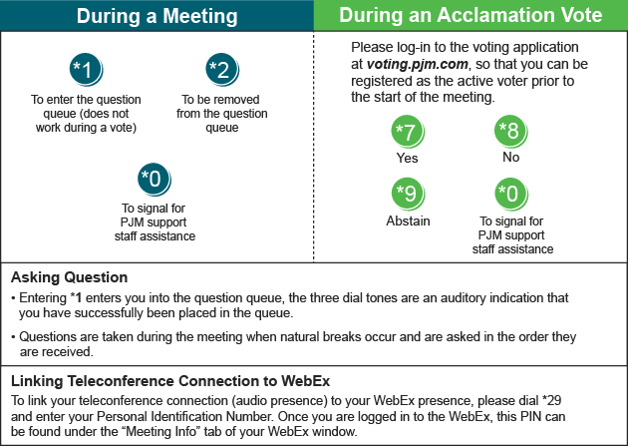

Provide feedback on the progress of this group: Facilitator Feedback Form
Visit learn.pjm.com, an easy-to-understand resource about the power industry and PJM’s role.

