Market Implementation Committee
WebEx Only
July 8 2020
9:00 a.m. – 4:00 p.m. EPT

Administration (9:00-9:05)
Bhavana Keshavamurthy will review the Antitrust, Code of Conduct, Public Meetings/Media Participation and the WebEx Participant Identification Requirements.

The Committee will be asked to approve the draft minutes from the June 3, 2020 Market Implementation Committee meeting.

- Lisa Morelli will review the MIC Work Plan.

Endorsements/Approvals (9:05 -10:10)
- Subcommittee Consolidation (9:05 – 9:20)
Scott Baker will propose the sunset of the Intermittent Resources Subcommittee (IRS) and review the charter for the Distributed and Inverter-based Resources Subcommittee (DIRS).
The committee will be asked to approve the sunset of the IRS and the DIRS charter at this meeting.

- PRD Credits Disposition (9:20 – 9:35)
Sharon Midgley, Exelon, will provide an overview of the Problem Statement and Issue Charge addressing the Price Responsive Demand (PRD) Credits Disposition.
The committee will be asked to approve the issue charge at this meeting.

- Transparency in Performance Assessment Interval Settlements (9:35 – 9:55)
Susan Kenney will review the problem statement and issue charge addressing additional transparency in settlement calculations for non-performance charge.
The committee will be asked to approve the issue charge at this meeting.

- Manual 14D and Manual 27 revisions (9:55 – 10:10)
Ray Fernandez will review updates to Manual 14D: Generator Operational Requirements and Manual 27: Open Access Transmission Tariff Accounting related to changes to deadlines for adjustments associated with finalizing the zonal network service peak load values. The Manual 14D revisions will be presented for endorsement at the July 9, 2020 Operating Committee meeting.
The committee will be asked to endorse the Manual 27 revisions at this meeting.

Working Item (10:10 – 10:55)
- Stability Limits in Markets and Operations (10:10 – 10:55)
- Ray Fernandez will provide education on the rules for compensating units for lost opportunity costs.
- Catherine Tyler, Monitoring Analytics will provide the IMM’s perspective on the issues with the status quo for stability limited units and the proposed capacity constraint package.
- Lisa Morelli will lead a discussion on the matrix.

Issue Tracking: Stability Limits in Markets and Operations

Additional Items (10:55 -12:30)
- Capacity Capability Senior Task Force Update (10:55 – 11:05)
Andrew Levitt will discuss work being done at the Capacity Capability Senior Task Force under the Market and Reliability Committee regarding Effective Load Carrying Capability (ELCC).

- MOPR Subsidy Guidance (11:05 – 11:25)
Alexandra Salaneck, Monitoring Analytics and Paul Scheidecker will provide an overview of the MOPR subsidy process to provide guidance to participants as to which programs constitute a state subsidy.

- Forward Looking Energy & Ancillary Services Offset Methodology (11:25 – 12:30)
Gary Helm will provide an update on the development of the forward-looking E&AS Offset methodology.

Informational Section
Interregional Coordination Update
Materials are posted as informational only.

Credit Subcommittee (CS)
Meeting materials will be posted to the CS website.

Demand Response Subcommittee (DRS)
Meeting materials will be posted to the DRS web site.

Intermittent Resources Subcommittee (IRS)
Meeting materials will be posted to the IRS web site.

Market Settlements Subcommittee (MSS)
Meeting materials are posted to the MSS web site.

Report on Market Operations
The Report on Market Operations will be reviewed during the MC Webinar.

Future Meeting Dates
August 5, 2020 | 9:00 a.m. | WebEx
September 2, 2020 | 9:00 a.m. | WebEx
October 7, 2020 | 9:00 a.m. | WebEx
November 5, 2020 | 9:00 a.m. | WebEx
December 2, 2020 | 9:00 a.m. | WebEx
Author: Nick DiSciullo

Antitrust:
You may not discuss any topics that violate, or that might appear to violate, the antitrust laws including but not limited to agreements between or among competitors regarding prices, bid and offer practices, availability of service, product design, terms of sale, division of markets, allocation of customers or any other activity that might unreasonably restrain competition. If any of these items are discussed the chair will re-direct the conversation. If the conversation still persists, parties will be asked to leave the meeting or the meeting will be adjourned.

Code of Conduct:
As a mandatory condition of attendance at today's meeting, attendees agree to adhere to the PJM Code of Conduct as detailed in PJM Manual M-34 section 4.5, including, but not limited to, participants' responsibilities and rules regarding the dissemination of meeting discussion and materials.

Public Meetings/Media Participation:
Unless otherwise noted, PJM stakeholder meetings are open to the public and to members of the media. Members of the media are asked to announce their attendance at all PJM stakeholder meetings at the beginning of the meeting or at the point they join a meeting already in progress. Members of the Media are reminded that speakers at PJM meetings cannot be quoted without explicit permission from the speaker. PJM Members are reminded that "detailed transcriptional meeting notes" and white board notes from "brainstorming sessions" shall not be disseminated. Stakeholders are also not allowed to create audio, video or online recordings of PJM meetings. PJM may create audio, video or online recordings of stakeholder meetings for internal and training purposes, and your participation at such meetings indicates your consent to the same.
Participant Identification in WebEx:
When logging into the WebEx desktop client, please enter your real first and last name as well as a valid email address. Be sure to select the “call me” option.
PJM support staff continuously monitors WebEx connections during stakeholder meetings. Anonymous users or those using false usernames or emails will be dropped from the teleconference.

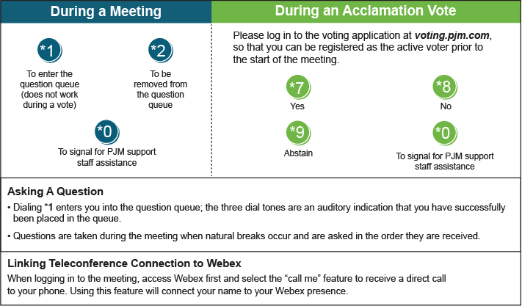

Provide feedback on the progress of this group: Facilitator Feedback Form
Visit learn.pjm.com, an easy-to-understand resource about the power industry and PJM’s role.

