Market Implementation Committee

WebEx Only

April 13, 2022

9:00 a.m. – 3:30 p.m. EPT

Administration (9:00 – 9:10)

Nicholas DiSciullo will review the Antitrust, Code of Conduct, Public Meetings/Media Participation and the WebEx Participant Identification Requirements.

The Committee will be asked to approve the draft minutes from the March 9, 2022 Market Implementation Committee.

1. Lisa Morelli will provide an update on the MIC Work Plan.
2. Foluso Afelumo will provide an update on Internet Explorer 11 End of Life support and its impacts to PJM applications.

Endorsements/Approvals (9:10 – 9:25)

1. **Start-Up Cost Offer Development (9:10 – 9:25)**

Tom Hauske will review the Revised PJM/IMM Proposal addressing Start-Up Cost Offer Development developed through the Cost Development Subcommittee.

**The committee will be asked to endorse the proposal at this meeting.**

First Readings (9:25 – 10:40)

1. **Manual 29 Revisions (9:25 – 9:40)**

Natasha Holter will provide a first read of revisions to Manual 29: Billing as part of the periodic review. The committee will be asked to endorse the revisions at its next meeting.

1. **Manual 11 and Manual 28: Stability Limit Changes (9:40 – 10:10)**

Zhenyu Fan and Rebecca Stadelmeyer will provide education and a first read of conforming updates to Manual 11: Energy & Ancillary Services Market Operations and Manual 28: Operating Agreement Accounting. The committee will be asked to endorse these revisions at its next meeting.

[Issue Tracking: Stability Limits in Markets and Operations](https://www.pjm.com/committees-and-groups/issue-tracking/issue-tracking-details.aspx?Issue=e2cf01c5-2504-49d7-8b1a-66b867bba081)

1. **Manual 11 and Manual 28: Intelligent Reserve Deployment Changes (10:10 – 10:40)**

Damon Fereshetian and Rebecca Stadelmeyer will provide education and a first read of updates to Manual 11: Energy & Ancillary Services Market Operations and Manual 28: Operating Agreement Accounting. The committee will be asked to endorse these revisions at its next meeting.

[Issue Tracking: Synchronized Reserve Event Actions and Expectations](https://pjm.com/committees-and-groups/issue-tracking/issue-tracking-details.aspx?Issue=88b492a5-1547-4558-a242-456d99b87a37)

Working Items – Part 1 (10:40 – 12:40)

1. **Market Suspension (10:40 – 11:40)**
   1. Stefan Starkov will provide an update on the PJM/IMM Package.
   2. Lisa Morelli will facilitate a discussion to review and develop additional proposals on the Market Suspension matrix as part of the Consensus Based Issue Resolution process. Additional solution options and proposals may be provided prior to and during the meeting.

[Issue Tracking: Rules Related to Market Suspension](https://www.pjm.com/committees-and-groups/issue-tracking/issue-tracking-details.aspx?Issue=214df9c5-db87-4a02-84be-b917c118d6ed)

1. **Capacity Offer Opportunities for Generation with Co-Located Load (11:40 – 12:40)**

Lisa Morelli will facilitate a discussion to identify additional interests, design components and begin developing solution options for the Capacity Offer Opportunities for Generation with Co-Located Load matrix.

[Issue Tracking: Capacity Offer Opportunities for Generation with Co-Located Load](https://www.pjm.com/committees-and-groups/issue-tracking/issue-tracking-details.aspx?Issue=6897c7e7-d8b7-438e-9e3f-b6099f9dd7ec)

Lunch (12:40 – 1:10)

Additional Items (1:10 – 1:30)

1. **Energy Market Must Offer Requirement Education (1:10 – 1:25)**

Roger Cao, PJM, will provide education on the energy must offer requirement for committed Generation Capacity Resources.  The intention of this education is to ensure that market participants understand the energy must offer rules and how to comply with them.

1. Cost Development Subcommittee Update (1:25 – 1:30)

Nicole Scott will provide an informational update on the work to be performed at the Cost Development Subcommittee.

Working Items – Part 2 (1:30 – 3:30)

1. **Operating Reserve Clarification for Resources Operating as Requested by PJM (1:30 – 3:30)**
   1. Brian Weathers will provide education on the current Tariff, Operating Agreement and Manual requirements regarding the calculation of Balancing Operating Reserve Credits, specifically as it relates to eligibility for Balancing Operating Reserve Credits and the MW level to which resources are made whole.
   2. Joel Luna, IMM, will provide education on examples of situations where resources do not follow dispatch and receive uplift.

[Issue Tracking: Operating Reserve Clarification for Resources Operating as Requested by PJM](https://www.pjm.com/committees-and-groups/issue-tracking/issue-tracking-details.aspx?Issue=6897c7e7-d8b7-438e-9e3f-b6099f9dd7ec)

Informational Section

**Interregional Coordination Update**

Materials are posted as informational only.

**Fast Start Pricing Monthly Metrics Update**

Materials are posted as informational only.

**Manual 3: Transmission Operations Periodic Review Update**

Materials are posted as informational only.

**nGEM Project Update**

Materials are posted as informational only.

**ARR FTR Market Task Force (AFMTF)**   
Meeting materials are posted to the [AFMTF website](https://www.pjm.com/committees-and-groups/task-forces/afmtf).

**Reactive Power Compensation Task Force (RPCTF)**   
Meeting materials are posted to the [RPCTF website.](https://www.pjm.com/committees-and-groups/task-forces/rpctf)

**Cost Development Subcommittee (CDS)**   
Meeting materials are posted to the [CDS website](https://www.pjm.com/committees-and-groups/subcommittees/cds).

**Demand Response Subcommittee (DRS)**   
Meeting materials are posted to the [DRS website](http://www.pjm.com/committees-and-groups/subcommittees/drs.aspx).

**DER & Inverter-based Resources Subcommittee (DIRS)**

Meeting materials are posted to the [DIRS website.](https://www.pjm.com/committees-and-groups/subcommittees/dirs.aspx)

**Market Settlements Subcommittee (MSS)**

Meeting materials are posted to the [MSS website](http://www.pjm.com/committees-and-groups/subcommittees/mss.aspx).

OC/MIC Fuel Requirements for Black Start Resources

Meeting materials are posted to the [Operating Committee website](https://www.pjm.com/committees-and-groups/committees/oc).

Report on Market Operations

The Report on Market Operations will be reviewed during the [MC Webinar](http://www.pjm.com/committees-and-groups/committees/mc.aspx).

|  |  |  |  |  |
| --- | --- | --- | --- | --- |
| **Future Meeting Dates and Materials** | | | **Materials Due  to Secretary** | **Materials Published** |
| Date | Time | Location | 5 p.m. | 4 p.m. |
| May 11 | 9 a.m. | WebEx | April 29 | May 4 |
| June 8 | 9 a.m. | WebEx / Conference & Training Center | May 26 | June 1 |
| July 13 | 9 a.m. | WebEx / Conference & Training Center | June 30 | July 6 |
| August 10 | 9 a.m. | WebEx / Conference & Training Center | July 29 | August 3 |
| September 7 | 9 a.m. | WebEx / Conference & Training Center | August 26 | August 31 |
| October 6 | 9 a.m. | WebEx / Conference & Training Center | September 26 | September 29 |
| November 2 | 9 a.m. | WebEx / Conference & Training Center | October 21 | October 26 |
| December 7 | 9 a.m. | WebEx / Conference & Training Center | November 23 | November 30 |

Author: Nicholas DiSciullo

Antitrust:

You may not discuss any topics that violate, or that might appear to violate, the antitrust laws including but not limited to agreements between or among competitors regarding prices, bid and offer practices, availability of service, product design, terms of sale, division of markets, allocation of customers or any other activity that might unreasonably restrain competition. If any of these items are discussed the chair will re-direct the conversation. If the conversation still persists, parties will be asked to leave the meeting or the meeting will be adjourned.

Code of Conduct:

As a mandatory condition of attendance at today's meeting, attendees agree to adhere to the PJM Code of Conduct as detailed in PJM Manual M-34 section 4.5, including, but not limited to, participants' responsibilities and rules regarding the dissemination of meeting discussion and materials.

Public Meetings/Media Participation:

Unless otherwise noted, PJM stakeholder meetings are open to the public and to members of the media. Members of the media are asked to announce their attendance at all PJM stakeholder meetings at the beginning of the meeting or at the point they join a meeting already in progress. Members of the Media are reminded that speakers at PJM meetings cannot be quoted without explicit permission from the speaker. PJM Members are reminded that "detailed transcriptional meeting notes" and white board notes from "brainstorming sessions" shall not be disseminated. Stakeholders are also not allowed to create audio, video or online recordings of PJM meetings. PJM may create audio, video or online recordings of stakeholder meetings for internal and training purposes, and your participation at such meetings indicates your consent to the same.

Participant Identification in WebEx:

When logging into the WebEx desktop client, please enter your real first and last name as well as a valid email address. Be sure to select the “call me” option.

PJM support staff continuously monitors WebEx connections during stakeholder meetings. Anonymous users or those using false usernames or emails will be dropped from the teleconference.

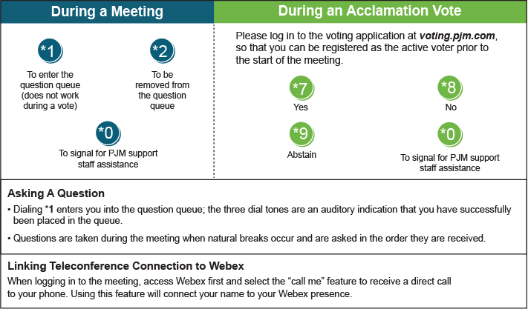

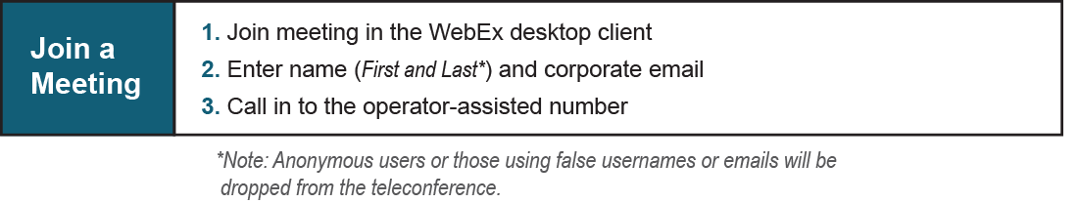

Provide feedback on the progress of this group: [*Facilitator Feedback Form*](https://www.pjm.com/committees-and-groups/committees/form-facilitator-feedback.aspx)   
Visit [*learn.pjm.com*](https://learn.pjm.com/), an easy-to-understand resource about the power industry and PJM’s role.