Markets and Reliability Committee
Webex Only
August 20, 2020
9:00 a.m. – 11:55 a.m.
*Operator assisted phone lines will be opened 30 minutes prior to the start of the meeting. Due to the high volume of remote participation, stakeholders are asked to connect early to allow additional time for operator queue processing.

Administration (9:00-9:05)
Welcome, announcements and Anti-trust, Code of Conduct, and Public Meetings/Media Participation – Stu Bresler and Dave Anders

Consent Agenda (9:05-9:10)
- Approve minutes of the July 23, 2020 meeting of the Markets and Reliability Committee (MRC).
- Endorse proposed revisions to Manuals 14A, 14B and 14G related to FERC’s Order on PJM’s Order 845 Second Compliance Filing.
- Endorse proposed Operating Agreement (OA) revisions to support improving situational awareness with the Dispatch Interactive Map Application (DIMA).
Issue Tracking: Improving Situational Awareness with the Dispatch Interactive Map Application (DIMA)

Endorsements/Approvals (9:10-10:55)
- Manuals 14D and 27 – Zonal NSPL Values (9:10-9:25)
Ray Fernandez will review proposed revisions to Manual 14D: Generator Operational Requirements and Manual 27: Open Access Transmission Tariff Accounting related to changes to deadlines for adjustments associated with finalizing the zonal network service peak load values. The committee will be asked to endorse the proposed revisions.
- Market Efficiency Process Enhancement Task Force (9:25-10:10)
Jack Thomas will provide an update of the Phase 3 work completed at the Market Efficiency Process Enhancement Task Force (MEPETF).
Issue Tracking: RTEP Market Efficiency Analysis
- Jack Thomas and Nick Dumitriu will review solution packages A4 and A1 and corresponding proposed OA revisions related to Regional Targeted Market Efficiency Projects (RTMEP). The committee will be asked to endorse a proposed solution and proposed OA revisions.
- Jack Thomas and Nick Dumitriu will review solution packages B4 and B1 and corresponding proposed OA revisions related to the Benefit Calculation. The committee will be asked to endorse a proposed solution and proposed OA revisions.
- Jack Thomas and Nick Dumitriu will review solution package C1 and corresponding proposed OA revisions related to the Window for Capacity Drivers. The committee will be asked to endorse the proposed solution and proposed OA revisions.
- Risk Management Committee Charter (10:10-10:25)
Jennifer Tribulski will provide an update regarding potential revisions to the Credit Subcommittee Charter including an expansion to incorporate risk and a proposed change in parent reporting structure. The resulting charter is being renamed Risk Management Committee Charter. The committee will be asked to endorse the revised charter.

- Critical Infrastructure Stakeholder Oversight Senior Task Force (10:25-10:55)
Greg Poulos and Erik Heinle will seek to revoke the related Issue Charge being worked at the Special PC Sessions. They will also seek endorsement of a Problem Statement and replacement Issue Charge at this meeting. The committee will be asked to endorse the revocation and the replacement Issue Charge.
Issue Tracking: Critical Infrastructure Stakeholder Oversight

First Readings (10:55-11:20)
- Cost Development Subcommittee (10:45-11:05)
Glen Boyle will review proposed revisions to the Cost Development Subcommittee charter. The committee will be asked to endorse the revised charter at its next meeting.
- PJM Manuals (11:05-11:20)
  - Shaun Murphy will review proposed revisions to Manual 01: Control Center and Data Exchange Requirements and Manual 14B: PJM Region Transmission Planning Process addressing PMU Placement in RTEP Planning Process. The committee will be asked to endorse the revisions at its next meeting.

Informational Reports (11:20-11:55)
- Capacity Capability Senior Task Force (CCSTF) (11:20-11:40)
Melissa Pilong will provide an update of the work completed at the Capacity Capability Senior Task Force (CCSTF) including proposed solution package(s) and initial thoughts on corresponding Reliability Assurance Agreement (RAA) revisions. The committee will conduct a first read of proposed solutions and corresponding revisions at a special session of the MRC on August 31.
Issue Tracking: Effective Load Carrying Capability for Limited Duration Resources and Intermittent Resources

- FERC Transmission Orders Requiring Reallocations and Refunds (11:40-11:55)
Ray Fernandez will provide updates on cost allocation issues associated with multiple transmission orders (Dockets ER15-1387, ER15-1344, and ER18-680) from FERC that require resettlement.

Future Agenda Items (11:55)

Future Meeting Dates
September 17, 2020 | 9:00 a.m. | PJM Conference & Training Center/ WebEx
October 29, 2020 | 9:00 a.m. | PJM Conference & Training Center/ WebEx
November 19, 2020 | 9:00 a.m. | PJM Conference & Training Center/ WebEx
December 17, 2020 | 9:00 a.m. | PJM Conference & Training Center/ WebEx

Author: M. Greening

Antitrust:
You may not discuss any topics that violate, or that might appear to violate, the antitrust laws including but not limited to agreements between or among competitors regarding prices, bid and offer practices, availability of service, product design, terms of sale, division of markets, allocation of customers or any other activity that might unreasonably restrain competition. If any of these items are discussed the chair will re-direct the conversation. If the conversation still persists, parties will be asked to leave the meeting or the meeting will be adjourned.

Code of Conduct:
As a mandatory condition of attendance at today's meeting, attendees agree to adhere to the PJM Code of Conduct as detailed in PJM Manual M-34 section 4.5, including, but not limited to, participants' responsibilities and rules regarding the dissemination of meeting discussion and materials.

Public Meetings/Media Participation:
Unless otherwise noted, PJM stakeholder meetings are open to the public and to members of the media. Members of the media are asked to announce their attendance at all PJM stakeholder meetings at the beginning of the meeting or at the point they join a meeting already in progress. Members of the Media are reminded that speakers at PJM meetings cannot be quoted without explicit permission from the speaker. PJM Members are reminded that "detailed transcriptional meeting notes" and white board notes from "brainstorming sessions" shall not be disseminated. Stakeholders are also not allowed to create audio, video or online recordings of PJM meetings. PJM may create audio, video or online recordings of stakeholder meetings for internal and training purposes, and your participation at such meetings indicates your consent to the same.
Participant Identification in WebEx:
When logging into the WebEx desktop client, please enter your real first and last name as well as a valid email address. Be sure to select the “call me” option.
PJM support staff continuously monitors WebEx connections during stakeholder meetings. Anonymous users or those using false usernames or emails will be dropped from the teleconference.

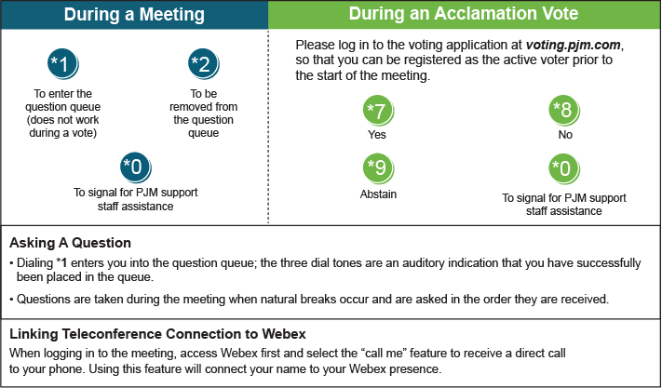

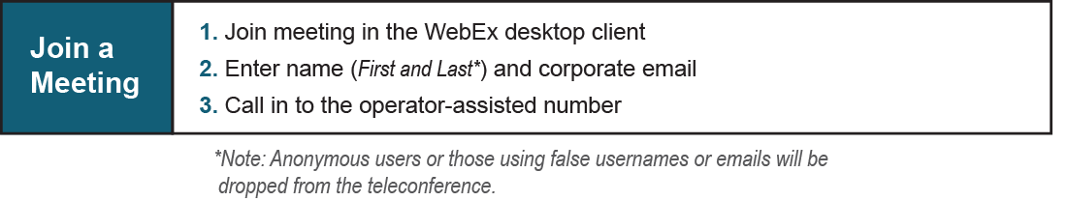
Provide feedback on the progress of this group: Facilitator Feedback Form
Visit learn.pjm.com, an easy-to-understand resource about the power industry and PJM’s role.

