Markets & Reliability Committee
Webex Only
May 26, 2021
9:00 a.m. – 11:35 a.m. EPT
*Operator assisted phone lines will be opened 30 minutes prior to the start of the meeting. Due to the high volume of remote participation, stakeholders are asked to connect early to allow additional time for operator queue processing.

Administration (9:00-9:05)
Welcome, announcements and Anti-trust, Code of Conduct, and Public Meetings/Media Participation – Stu Bresler and Dave Anders

Consent Agenda (9:05-9:10)
- Approve minutes of the April 21, 2021 meeting of the Markets and Reliability Committee (MRC).
- Endorse proposed revisions to Manual 03: Transmission Operations resulting from its periodic cover to cover review.
- Endorse proposed revisions to Manual 11: Energy & Ancillary Services Market Operations, Manual 14D: Generator Operational Requirements and Manual 18: PJM Capacity Market addressing Public Distribution Microgrids.
- Endorse proposed revisions to Manual 21: Rules and Procedures for Determination of Generating Capability resulting from its periodic cover to cover review.
- Endorse proposed revisions to Manual 36: System Restoration resulting from its periodic cover to cover review.

Endorsements (9:10-9:55)
- New Service Requests Deficiency Review Requirements (9:10-9:30)
Jason Connell will review a proposed solution to address new service requests deficiency review requirements. The committee will be asked to approve the proposed solution and Tariff revisions.
- Critical Infrastructure Stakeholder Oversight (CISO) (9:30-9:55)
Mike Herman will review the proposed solutions to address the Avoidance of future CIP-014 facilities. The committee will be asked to endorse the proposed Avoidance solution and corresponding Manual and Operating Agreement (OA) revisions.
Issue Tracking: Critical Infrastructure Stakeholder Oversight

First Readings (9:55-10:50)
- Interconnection Construction Service Agreement Superseding Language and Automatic Termination Provision (9:55-10:15)
Mark Sims will review a proposed solution to address concerns associated with the pro forma Interconnection Construction Service Agreement’s (a) lack of superseding language and (b) current automatic termination provision. The committee will be asked to endorse the proposed solution and Tariff revisions at its next meeting.
- Reserve Price Formation Issue Charge (10:15-10:40)
Adrien Ford, ODEC, and John Rohrbach, representing SMECO, will present a first read of a Problem Statement and Issue Charge regarding the PJM Operating Reserve Demand Curve and Transmission Constraint Penalty Factors on behalf of the multiple sponsors. The committee will be asked to approve the Issue Charge at its next meeting.
- PJM Manuals (10:40-10:50)
  - Nick Dumitriu will review proposed revisions to Manual 14B: PJM Region Transmission Planning Process and Manual 14F: Competitive Planning Process conforming to the MEPETF capacity driver docket (ER21-162). The committee will be asked to endorse the proposed revisions at its next meeting.

Informational Reports (10:50-11:35)
- Update on Revised ELCC Proposal (10:50-11:20)
Thomas DeVita and Andrew Levitt will describe the revised ELCC proposal and will summarize comments it has received from stakeholders on the substance of the filing. In response to FERC’s order rejecting PJM’s prior ELCC proposal, PJM intends to file this revised proposal with FERC on June 1 under Section 205 of the Federal Power Act.
Issue Tracking: Effective Load Carrying Capability for Limited Duration Resources and Intermittent Resources
- Stakeholder Process Issues Timing Review and Sequencing (11:20-11:35)
Dave Anders will discuss a recent review of the stakeholder process calendar and sequencing current and pending stakeholder issues.

Future Agenda Items (11:35)

Future Meeting Dates and Materials |  |  |  | Materials Due  to Secretary | Materials Published
Date | Time | Location
June 23, 2021 | 9:00 a.m. |  | WebEx | June 11, 2021 | June 16, 2021
July 28, 2021 | 9:00 a.m. |  | WebEx | July 16, 2021 | July 21, 2021
August 25, 2021 | 9:00 a.m. |  | WebEx | August 13, 2021 | August 18, 2021
September 29, 2021 | 9:00 a.m. |  | WebEx | September 17, 2021 | September 22, 2021
October 20, 2021 | 9:00 a.m. |  | WebEx | October 8, 2021 | October 13, 2021
November 17, 2021 | 9:00 a.m. |  | WebEx | November 5, 2021 | November 10, 2021
December 15, 2021 | 9:00 a.m. |  | WebEx | December 3, 2021 | December 8, 2021

Author: M. Greening

Antitrust:
You may not discuss any topics that violate, or that might appear to violate, the antitrust laws including but not limited to agreements between or among competitors regarding prices, bid and offer practices, availability of service, product design, terms of sale, division of markets, allocation of customers or any other activity that might unreasonably restrain competition. If any of these items are discussed the chair will re-direct the conversation. If the conversation still persists, parties will be asked to leave the meeting or the meeting will be adjourned.

Code of Conduct:
As a mandatory condition of attendance at today's meeting, attendees agree to adhere to the PJM Code of Conduct as detailed in PJM Manual M-34 section 4.5, including, but not limited to, participants' responsibilities and rules regarding the dissemination of meeting discussion and materials.

Public Meetings/Media Participation:
Unless otherwise noted, PJM stakeholder meetings are open to the public and to members of the media. Members of the media are asked to announce their attendance at all PJM stakeholder meetings at the beginning of the meeting or at the point they join a meeting already in progress. Members of the Media are reminded that speakers at PJM meetings cannot be quoted without explicit permission from the speaker. PJM Members are reminded that "detailed transcriptional meeting notes" and white board notes from "brainstorming sessions" shall not be disseminated. Stakeholders are also not allowed to create audio, video or online recordings of PJM meetings. PJM may create audio, video or online recordings of stakeholder meetings for internal and training purposes, and your participation at such meetings indicates your consent to the same.
Participant Identification in Webex:
When logging into the Webex desktop client, please enter your real first and last name as well as a valid email address. Be sure to select the “call me” option.
PJM support staff continuously monitors Webex connections during stakeholder meetings. Anonymous users or those using false usernames or emails will be dropped from the teleconference.

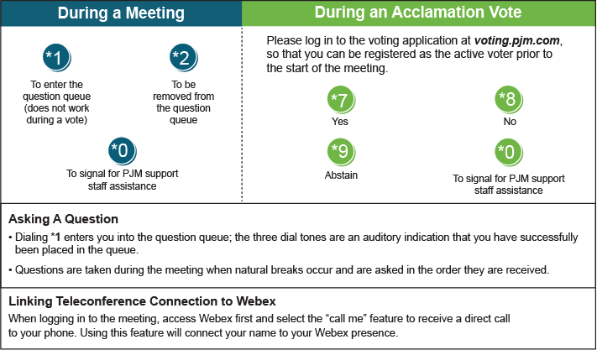

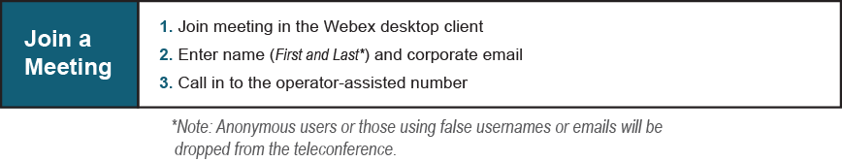
Provide feedback on the progress of this group: Facilitator Feedback Form
Visit learn.pjm.com, an easy-to-understand resource about the power industry and PJM’s role.

