Markets & Reliability Committee
Webex Only
September 29, 2021
9:00 a.m. – 1:15 p.m. EPT
*Operator assisted phone lines will be opened 30 minutes prior to the start of the meeting. Due to the high volume of remote participation, stakeholders are asked to connect early to allow additional time for operator queue processing.

Administration (9:00-9:05)
Welcome, announcements and Anti-trust, Code of Conduct, and Public Meetings/Media Participation – Stu Bresler and Dave Anders

Consent Agenda (9:05-9:10)
- Approve minutes of the August 25, 2021 meeting of the Markets and Reliability Committee (MRC).
- Endorse revisions to the Regional Transmission and Energy Scheduling Practices document.

Endorsements (9:10-10:40)
- Energy Price Formation Charter (9:10-9:25)
Susan Kenney will review proposed revisions to the EPFSTF Charter. The committee will be asked to approve a proposed Charter.
Issue Tracking: Operating Reserve Demand Curve & Transmission Constraint Penalty Factors
- Natural Gas and Electric Markets Issue Charge (9:25-9:40)
Jim Davis, Dominion Energy, will review a Problem Statement and Issue Charge related to natural gas and electric market coordination. The committee will be asked to approve the proposed Issue Charge.
- Market Suspension (9:40-10:00)
Stefan Starkov will review a proposed solution to address rules related to market suspension. The committee will be asked to endorse the proposed solution and OA revisions.
Issue Tracking: Rules Related to Market Suspension
- Initial Margining Solution (10:00-10:40)
- Anita Patel will provide an update on the conclusion of the Financial Risk Mitigation Senior Task Force (FRMSTF).
- Jessica Troiano will review proposed Tariff revisions supporting the FRMSTF endorsed proposal.
- James Ramsey, Perast Capital, will discuss perspectives on the Main Motion.
- Greg Poulos, on behalf of New Jersey Division of the Rate Counsel, will move the PJM Proposal (FRMSTF Package A) as an alternative motion.
The committee will be asked to endorse a proposed solution and Tariff revisions. Upon endorsement of a proposed solution, the committee will also be asked to approve the sunset of the FRMSTF in an additional vote.
Issue Tracking: Financial Risk Mitigation

First Readings (10:40-12:45)
- Resource Adequacy Charter (10:40-11:05)
Dave Anders will review a proposed Charter addressing resource adequacy topics discussed in the Capacity Workshops. The committee will be asked to endorse the proposed Charter at its next meeting.
- 2021 Reserve Requirement Study Results (11:05-11:20)
Patricio Rocha Garrido will review the 2021 Reserve Requirement Study preliminary results (IRM, FPR). The committee will be asked to endorse the study results at its next meeting.
- Behind the Meter Generation Business Rules on Status Changes (11:20-11:35)
Theresa Esterly will review a proposed updates addressing behind the meter generation business rules on status changes. The committee will be asked to endorse the proposed updates and corresponding Manual and Tariff revisions at its next meeting.
Issue Tracking: Behind the Meter Generation Business Rules on Status Changes
- Incremental & No Load Energy Offer (11:35-11:50)
Tom Hauske will review proposed revisions in Manual 15: Cost Development Guidelines, the Operating Agreement, and the Tariff to address incremental and no load energy offers. The committee will be asked to endorse the revisions at its next meeting.
- Solar-Battery Hybrid Resources (11:50-12:10)
Andrew Levitt will review a proposed solution package to address various aspects of market participation by solar-battery hybrid resources. The committee will be asked to endorse the proposed solution and corresponding Tariff revisions at its next meeting.
Issue Tracking: Solar-Battery Hybrid Resources
- Undefined Regulation Mileage Ratio Calculation (12:10-12:30)
- Michael Olaleye will review the PJM proposal addressing the undefined regulation mileage ratio calculation.
- Adrien Ford, ODEC, will offer the IMM Proposal for alternative consideration.
The committee will be asked to endorse a proposed solution and corresponding Manual and Tariff revisions at its next meeting.
Issue Tracking: Undefined Regulation Mileage Ratio Calculation
- Energy Efficiency (EE) Addback (12:30-12:45)
Jeff Bastian will provide a first read of the IMM/PJM proposal addressing the calculation of the EE Addback. The committee will be asked to endorse the proposed solution and corresponding Manual revisions at its next meeting.
Issue Tracking: Energy Efficiency Addback
- ARR/FTR Market Task Force Update (12:45-1:15)
- Dave Anders and Brian Chmielewski will provide an overview of the activities of the task force and proposals developed through the ARR/FTR Market Task Force. Brian will provide additional detail on the PJM/Joint Stakeholder proposal.
- Joe Bowring, IMM, will provide additional detail on the IMM proposal.
The committee will be asked to endorse a proposed solution and corresponding Manual and Tariff revisions at its next meeting.
Issue Tracking: ARR/FTR Market Review

Future Agenda Items (1:15)

Future Meeting Dates and Materials |  |  |  | Materials Due  to Secretary | Materials Published
Date | Time | Location
October 20, 2021 | 9:00 a.m. |  | WebEx | October 8, 2021 | October 13, 2021
November 17, 2021 | 9:00 a.m. |  | WebEx | November 5, 2021 | November 10, 2021
December 15, 2021 | 9:00 a.m. |  | WebEx | December 3, 2021 | December 8, 2021

Author: M. Greening

Antitrust:
You may not discuss any topics that violate, or that might appear to violate, the antitrust laws including but not limited to agreements between or among competitors regarding prices, bid and offer practices, availability of service, product design, terms of sale, division of markets, allocation of customers or any other activity that might unreasonably restrain competition. If any of these items are discussed the chair will re-direct the conversation. If the conversation still persists, parties will be asked to leave the meeting or the meeting will be adjourned.

Code of Conduct:
As a mandatory condition of attendance at today's meeting, attendees agree to adhere to the PJM Code of Conduct as detailed in PJM Manual M-34 section 4.5, including, but not limited to, participants' responsibilities and rules regarding the dissemination of meeting discussion and materials.

Public Meetings/Media Participation:
Unless otherwise noted, PJM stakeholder meetings are open to the public and to members of the media. Members of the media are asked to announce their attendance at all PJM stakeholder meetings at the beginning of the meeting or at the point they join a meeting already in progress. Members of the Media are reminded that speakers at PJM meetings cannot be quoted without explicit permission from the speaker. PJM Members are reminded that "detailed transcriptional meeting notes" and white board notes from "brainstorming sessions" shall not be disseminated. Stakeholders are also not allowed to create audio, video or online recordings of PJM meetings. PJM may create audio, video or online recordings of stakeholder meetings for internal and training purposes, and your participation at such meetings indicates your consent to the same.
Participant Identification in Webex:
When logging into the Webex desktop client, please enter your real first and last name as well as a valid email address. Be sure to select the “call me” option.
PJM support staff continuously monitors Webex connections during stakeholder meetings. Anonymous users or those using false usernames or emails will be dropped from the teleconference.

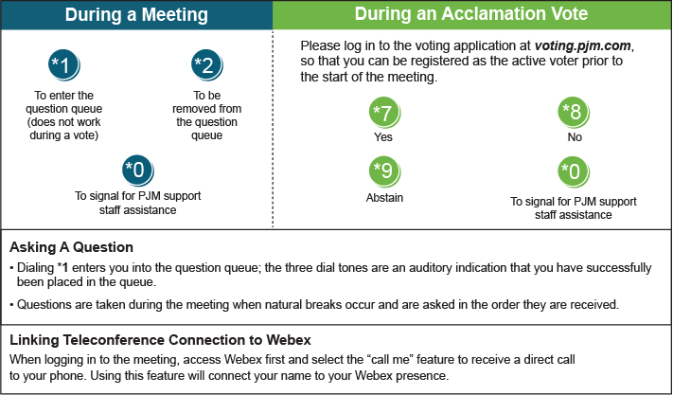

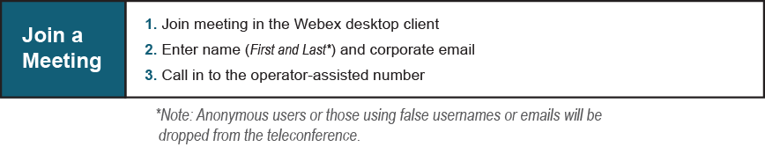
Provide feedback on the progress of this group: Facilitator Feedback Form
Visit learn.pjm.com, an easy-to-understand resource about the power industry and PJM’s role.

