Markets & Reliability Committee
Webex Only
March 23, 2022
9:00 a.m. – 12:40 p.m. EPT
*Operator assisted phone lines will be opened 30 minutes prior to the start of the meeting. Due to the high volume of remote participation, stakeholders are asked to connect early to allow additional time for operator queue processing.

Administration (9:00-9:15)
Welcome, announcements and Anti-trust, Code of Conduct, and Public Meetings/Media Participation – Stu Bresler and Dave Anders

Consent Agenda (9:15-9:20)
- Approve minutes of the February 24, 2022 meeting of the Markets and Reliability Committee (MRC).
- Endorse proposed revisions to Manual 12: Balancing Operations resulting from its periodic review.
- Endorse proposed revisions to Manual 13: Emergency Operations resulting from its periodic review.
- Endorse proposed revisions to Manual 18: PJM Capacity Market conforming with PJM’s 7/30/21 filing to reform application of the MOPR, PJM’s 10/21 compliance filing made in accordance with FERC’s 9/2/21 Order to amend the default MSOC, FERC’s 12/22/21 order directing PJM to reinstate the historic net EAS methodology, and FERC’s 1/20/22 order directing PJM to remove the 10% adder from the net EAS calculation for the reference resource CT.
- Endorse proposed revisions to Manual 37: Reliability Coordination resulting from its periodic review.

Endorsements (9:20-10:15)
- Pseudo Modeled Combined Cycle Minimum Run Time Guidance (9:20-9:40)
Tom Hauske will review a proposed solution and corresponding revisions to Manual 11: Energy & Ancillary Services Market Operations addressing Pseudo Modeled Combined Cycle Minimum Run Time Guidance. The committee will be asked to endorse the proposal and corresponding Manual 11 revisions.
Issue Tracking: Pseudo Modeled Combined Cycle Minimum Run Time Guidance
- Capacity Capability Senior Task Force (CCSTF) Sunset (9:40-9:50)
Melissa Pilong will seek a sunset of the Capacity Capability Senior Task Force (CCSTF). The committee will be asked to endorse the sunset.
Issue Tracking: Effective Load Carrying Capability for Limited Duration Resources and Intermittent Resources
- Max Emergency Changes (9:50-10:15)
- Chris Pilong will review proposed revisions to Manual 13: Emergency Operations addressing the extension of a temporary change to Max Emergency for gas combustion turbines and steam generators. The committee will be asked to approve an Issue Charge and endorse the proposed Manual 13 revisions as part of the Quick Fix process outlined in Section 8.6.1 of Manual 34.
- Chris Pilong will discuss a proposed Issue Charge to address this issue with a longer-term solution. The committee will be asked to approve the proposed Issue Charge.
Issue Tracking: Max Emergency Correction for Gas CTs

First Readings (10:15-12:40)
- Deactivation Process Timing (10:15-10:40)
Dave Egan will review a proposed solution to update the process timing for generation deactivations. The committee will be asked to endorse the proposed revisions and corresponding Tariff revisions at its next meeting.
Issue Tracking: Deactivation Analysis Period
- Interconnection Process Reform (10:40-11:25)
  - Jack Thomas will review proposed solutions to reform the interconnection process and address a transition to the new rules.
  - John Wieland, Leeward Renewable Energy, will review a proposed amendment on behalf of the PJM Interconnection Customers Coalition.
  - Jim Davis, Dominion Energy, and Alex Stern, PSEG, will review a proposed amendment.
The committee will be asked to endorse the proposed solution and corresponding Tariff revisions at its next meeting. Same day endorsement may be sought at the Members Committee for the Tariff revisions.
Issue Tracking: Interconnection Process Reform
- Documenting the Appropriate UFLS Requirements Applicable to EKPC (11:25-11:45)
Denise Foster Cronin, EKPC, will review a proposed solution and corresponding Operating Agreement (OA) revisions to appropriately document the underfrequency relay requirements applicable to EKPC. The committee will be asked to endorse the proposed solution and OA revisions at its next meeting.

- EPFSTF Charter (11:45-12:00)
Susan Kenney will review proposed revisions to the EPFSTF Charter. The committee will be asked to approve the proposed revisions at its next meeting.
Issue Tracking: Operating Reserve Demand Curve (ORDC) & Transmission Constraint Penalty Factors
- Procurement of Clean Resource Attributes (12:00-12:25)
Dave Anders, Walter Graf, and Matthew Bernstein will review a proposed RASTF Issue Charge addressing the procurement of clean resource attributes. The committee will be asked to approve the recommendation at its next meeting.
- Manuals (12:25-12:12:40)
  - Ryan Nice will review proposed revisions to Manual 01: Control Center and Data Exchange Requirements resulting from its periodic review. The committee will be asked to endorse the proposed Manual 01 revisions at its next meeting.
  - Joseph Hay will review proposed revisions to Manual 14F: Competitive Planning Process resulting from its periodic review. The committee will be asked to endorsed the proposed Manual 14F revisions at its next meeting.

Future Agenda Items (12:40)

Future Meeting Dates and Materials |  |  |  | Materials Due  to Secretary | Materials Published
Date | Time | Location
March 23, 2022 | 9:00 a.m. |  | Webex | March 11, 2022 | March 16, 2022
April 27, 2022 | 9:00 a.m. |  | Webex | April 15, 2022 | April 20, 2022
May 25, 2022 | 9:00 a.m. |  | PJM Conference & Training Center and WebEx | May 13, 2022 | May 18, 2022
June 29, 2022 | 9:00 a.m. |  | PJM Conference & Training Center and WebEx | June 17, 2022 | June 22, 2022
July 27, 2022 | 9:00 a.m. |  | PJM Conference & Training Center and WebEx | July 15, 2022 | July 20, 2022
August 24, 2022 | 9:00 a.m. |  | PJM Conference & Training Center and WebEx | August 12, 2022 | August 17, 2022
September 21, 2022 | 9:00 a.m. |  | PJM Conference & Training Center and WebEx | September 9, 2022 | September 14, 2022
* October 24, 2022 *tentative dates & time | * 1:00 p.m. |  | Off-site TBD | * October 12, 2022 | * October 17, 2022
November 16, 2022 | 9:00 a.m. |  | PJM Conference & Training Center and WebEx | November 4, 2022 | November 9, 2022
December 21, 2022 | 9:00 a.m. |  | PJM Conference & Training Center and WebEx | December 9, 2022 | December 14, 2022

Author: M. Greening

Antitrust:
You may not discuss any topics that violate, or that might appear to violate, the antitrust laws including but not limited to agreements between or among competitors regarding prices, bid and offer practices, availability of service, product design, terms of sale, division of markets, allocation of customers or any other activity that might unreasonably restrain competition. If any of these items are discussed the chair will re-direct the conversation. If the conversation still persists, parties will be asked to leave the meeting or the meeting will be adjourned.

Code of Conduct:
As a mandatory condition of attendance at today's meeting, attendees agree to adhere to the PJM Code of Conduct as detailed in PJM Manual M-34 section 4.5, including, but not limited to, participants' responsibilities and rules regarding the dissemination of meeting discussion and materials.

Public Meetings/Media Participation:
Unless otherwise noted, PJM stakeholder meetings are open to the public and to members of the media. Members of the media are asked to announce their attendance at all PJM stakeholder meetings at the beginning of the meeting or at the point they join a meeting already in progress. Members of the Media are reminded that speakers at PJM meetings cannot be quoted without explicit permission from the speaker. PJM Members are reminded that "detailed transcriptional meeting notes" and white board notes from "brainstorming sessions" shall not be disseminated. Stakeholders are also not allowed to create audio, video or online recordings of PJM meetings. PJM may create audio, video or online recordings of stakeholder meetings for internal and training purposes, and your participation at such meetings indicates your consent to the same.
Participant Identification in Webex:
When logging into the Webex desktop client, please enter your real first and last name as well as a valid email address. Be sure to select the “call me” option.
PJM support staff continuously monitors Webex connections during stakeholder meetings. Anonymous users or those using false usernames or emails will be dropped from the teleconference.

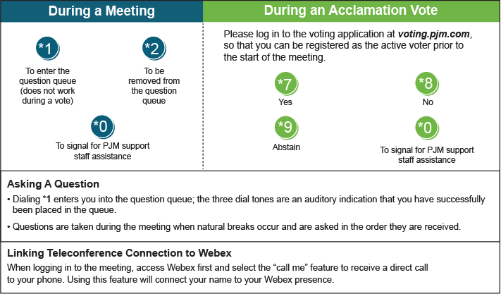

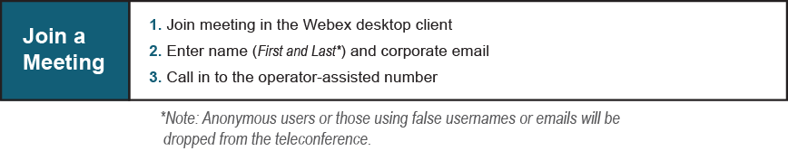
Provide feedback on the progress of this group: Facilitator Feedback Form
Visit learn.pjm.com, an easy-to-understand resource about the power industry and PJM’s role.

