Operating Committee

PJM Conference and Training Center
January 9, 2020
9:00 a.m. – 12:00 p.m. EPT

Administration (9:00-9:10)
Approve Operating Committee (OC) agenda for this meeting.
Review and approve draft minutes of the December 10 OC meeting.
Review of the OC work plan.

Review of Operations (9:10- 9:15)
Review of Operating Metrics
Ms. Stephanie Monzon, PJM, will review the December 2019 PJM operating metrics slides. Metrics will include PJM’s load forecast error, BAAL performance, transmission / generation outage statistics, and Perfect Dispatch historical performance. A proposed methodology updated for load forecast metric will be reviewed.

Endorsements/Approvals (9:15- 9:25)
PJM Manuals
  - Manual 38 Changes
Mr. Robert Dropkin, PJM, will review the proposed changes to PJM Manual 38: Operations Planning.
The Operating Committee will be asked to endorse these changes.

First Reading (9:25- 9:40)
PJM Manuals
  - Manual 40 Changes
Mr. Michael Hoke, PJM, will review the proposed changed to PJM Manual 40: Training and Certification Requirements. The Operating Committee will be asked to endorse these changes at the next meeting.

TO/TOP Matrix Review
Mr. Srinivas Kappagantula, PJM will review the TO/TOP Matrix V14. The Operating Committee will be asked for a recommendation to the Transmission Owner’s Agreement-Administrative Committee to approve the TO/TOP Matrix V14 with an effective date of 4/1/2020 at the next meeting.

Tool and Informational Updates (9:40 – 12:00)
System Operations Subcommittee (SOS) Report
Ms. Rebecca Carroll, PJM, will provide a summary of the most recent SOS meeting.

- Data Management Subcommittee (DMS) Report
Ms. Diane Lake, PJM, will provide an update on the recent DMS activities.

- System Resilience Update
Mr. Jonathon Monken, PJM, will provide an update on ongoing system resilience efforts.

- Load Forecasting Education
Ms. Elizabeth Anastasio, PJM, will provide education on load forecasting.

- FERC- NERC Cold Weather Report Update
Ms. Alpa Jani, PJM, will provide an update on the FERC-NERC Cold Weather Report.

- Unit Specific Parameter Update
Ms. Lauren Strella Wahba, PJM, will provide an update on Unit Specific Parameters.

- NERC Lessons Learned
Mr. Donnie Bielak, PJM, will provide a review of the recent NERC Lessons Learned.

- Reliability Compliance Update
Mr. Preston Walker, PJM, will provide an update on NERC, SERC and RFC standards, and other pertinent regulatory and compliance information, and solicit feedback from the members on Reliability Compliance efforts.
- Primary Frequency Response Sr. Task Force Update
Mr. Glen Boyle, PJM, will provide a review of the scheduled January MRC update on the PFRSTF.

OC Subcommittee/ Task Force Informational Section
System Operations Subcommittee (SOS): SOS Website

Data Management Subcommittee (DMS): DMS Website

Distributed Energy Resources Subcommittee (DERS): DERS Website

System Restoration Coordinators Subcommittee (SRCS): SRCS Website

Primary Frequency Response Sr. Task Force (PFRSTF): PFRSTF Website

Fuel Requirements for Black Start Resources: Fuel Requirements for Black Start Resources Issue Tracker

Future Meeting Dates
February 6, 2020 | 9:00 a.m. | PJM Conference & Training Center/ WebEx
March 12, 2020 | 9:00 a.m. | PJM Conference & Training Center/ WebEx
April 16, 2020 | 9:00 a.m. | PJM Conference & Training Center/ WebEx
May 14, 2020 | 9:00 a.m. | PJM Conference & Training Center/ WebEx
June 4, 2020 | 9:00 a.m. | PJM Conference & Training Center/ WebEx
July 9, 2020 | 9:00 a.m. | PJM Conference & Training Center/ WebEx
August 6, 2020 | 9:00 a.m. | PJM Conference & Training Center/ WebEx
September 3, 2020 | 9:00 a.m. | PJM Conference & Training Center/ WebEx
October 8, 2020 | 9:00 a.m. | PJM Conference & Training Center/ WebEx
November 6, 2020 | 9:00 a.m. | PJM Conference & Training Center/ WebEx
December 3, 2020 | 9:00 a.m. | PJM Conference & Training Center/ WebEx

Author: Danielle Croop

Antitrust:
You may not discuss any topics that violate, or that might appear to violate, the antitrust laws including but not limited to agreements between or among competitors regarding prices, bid and offer practices, availability of service, product design, terms of sale, division of markets, allocation of customers or any other activity that might unreasonably restrain competition. If any of these items are discussed the chair will re-direct the conversation. If the conversation still persists, parties will be asked to leave the meeting or the meeting will be adjourned.

Code of Conduct:
As a mandatory condition of attendance at today's meeting, attendees agree to adhere to the PJM Code of Conduct as detailed in PJM Manual M-34 section 4.5, including, but not limited to, participants' responsibilities and rules regarding the dissemination of meeting discussion and materials.

Public Meetings/Media Participation:
Unless otherwise noted, PJM stakeholder meetings are open to the public and to members of the media. Members of the media are asked to announce their attendance at all PJM stakeholder meetings at the beginning of the meeting or at the point they join a meeting already in progress. Members of the Media are reminded that speakers at PJM meetings cannot be quoted without explicit permission from the speaker. PJM Members are reminded that "detailed transcriptional meeting notes" and white board notes from "brainstorming sessions" shall not be disseminated. Stakeholders are also not allowed to create audio, video or online recordings of PJM meetings. PJM may create audio, video or online recordings of stakeholder meetings for internal and training purposes, and your participation at such meetings indicates your consent to the same.
Participant Identification in WebEx:
When logging into the WebEx desktop client, please enter your real first and last name as well as a valid email address. Be sure to select the “call me” option.
PJM support staff continuously monitors WebEx connections during stakeholder meetings. Anonymous users or those using false usernames or emails will be dropped from the teleconference.



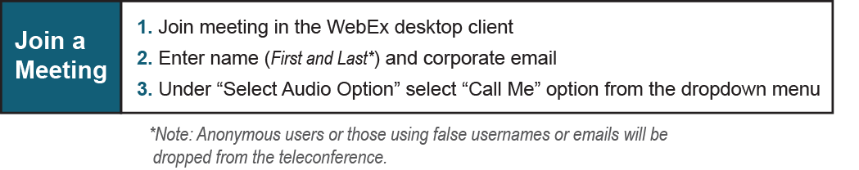
Provide feedback on the progress of this group: Facilitator Feedback Form
Visit learn.pjm.com, an easy-to-understand resource about the power industry and PJM’s role.

