Operating Committee
Webex Only
April 8, 2021
9:00 a.m. – 12:00 p.m. EDT

Administration (9:00-9:15)
Lauren Strella Wahba, PJM, will provide announcements; review the Antitrust, Code of Conduct, Public Meetings/Media Participation, and the WebEx Participant Identification Requirement.
  - Review and approve draft minutes from the March 11th OC meeting.

  - Review of the OC work plan.

  - Review of the OC Charter. The Operating committee will be asked to endorse the Charter at
its next meeting.

  - Dave Anders, PJM, will provide an update on the voting protocols for Board elections at the May
Members Committee meeting

Review of Operations (9:15-9:35)
PJM COVID-19 Update
Paul McGlynn, PJM, will provide an update on PJM’s operations plan in response to COVID-19. https://pjm.com/committees-and-groups/pandemic-coordination.aspx

Review of Operating Metrics
Stephanie Monzon, PJM, will review the March 2021 PJM operating metrics slides. Metrics will include PJM’s load forecast error, BAAL performance, and transmission / generation outage statistics.

Endorsements (9:35-9:50)
- IROL-CIP Cost Recovery
Darrell Frogg, PJM, will provide a second read of the Problem Statement and Issue Charge addressing IROL-CIP Cost Recovery. The Operating Committee will be asked to approve the Issue Charge at today’s meeting.

First Reading (9:50-10:20)
- Manual 01: Control Center and Data Exchange
Bilge Derin, PJM, will provide an update on the periodic review of Manual 01. No edits were found to be required in the review; therefore no vote will be required.
- Manual 03: Transmission Operations
Lagy Mathew, PJM, will review Manual 03 changes. The Operating Committee will be asked to endorse these changes at its next meeting.
- Manual 36: System Restoration
Rich Brown, PJM, will review Manual 36 changes. The Operating Committee will be asked to endorse these changes at its next meeting.

Informational Update (10:20-12:00)
- System Operations Subcommittee (SOS) Report
Rebecca Carroll, PJM, will provide a summary of the most recent SOS meeting.

- Real Time Value (RTV) Markets Gateway Change
Tong Zhao, PJM, will provide a review of the recent modification to Markets Gateway following the change to the RTV market rules.

- Dynamic Line Rating (DLR)
Shaun Murphy, PJM, will provide a recap of the OC Special Session on Dynamic Line Ratings Education held on March 30, 2021 and review proposed next steps.

- Synchrophasor Project Update
Shaun Murphy, PJM, will review recent activities around PMUs at PJM.

- M34 Proposed Posting Timeline
Michele Greening, PJM, will review information related to a proposed posting timeline trial period.

- Emerging Technologies Forum Survey
Scott Baker, PJM, will provide an informational announcement about a forthcoming stakeholder survey related to emerging technologies.

- Winter Operations Review
Rebecca Carroll, PJM, will review the 2020-2021 Winter Operations Summary.

- Winter Lessons Learned
Paul McGlynn, PJM, will discuss lessons learned from the 2020-2021 winter season.

- NERC Lessons Learned
Donnie Bielak with review the latest posted NERC Lessons Learned reports.

17. Reliability Compliance Update
Becky Davis, PJM, will provide an update on NERC, SERC and RFC standards, and other pertinent regulatory and compliance information, and solicit feedback from the members on Reliability Compliance efforts.

Informational Only Postings
18. PJM Manual 03 Attachment E Automatic Sectionalizing Schemes
The PJM Manual 03 Attachment E Automatic Sectionalizing Schemes Pending Approval and Recent
Changes document has been posted as an Information Only item to the April OC meeting website.

OC Subcommittee/ Task Force Informational Section
System Operations Subcommittee (SOS): SOS Website

Data Management Subcommittee (DMS): DMS Website

DER & Inverter-Based Resources Subcommittee (DIRS): DIRS Website

System Restoration Coordinators Subcommittee (SRCS): SRCS Website

Fuel Requirements for Black Start Resources: Fuel Reqt. for Black Start Resources Issue Tracker

Future Meeting Dates
May 14, 2021 | 9:00 a.m. | WebEx
June 10, 2021 | 9:00 a.m. | WebEx
July 15, 2021 | 9:00 a.m. | WebEx
August 12, 2021 | 9:00 a.m. | WebEx
September 10, 2021 | 9:00 a.m. | WebEx
October 07, 2021 | 9:00 a.m. | WebEx
November 04, 2021 | 9:00 a.m. | WebEx
December 02, 2021 | 9:00 a.m. | WebEx

Author: L. Strella Wahba

Antitrust:
You may not discuss any topics that violate, or that might appear to violate, the antitrust laws including but not limited to agreements between or among competitors regarding prices, bid and offer practices, availability of service, product design, terms of sale, division of markets, allocation of customers or any other activity that might unreasonably restrain competition. If any of these items are discussed the chair will re-direct the conversation. If the conversation still persists, parties will be asked to leave the meeting or the meeting will be adjourned.

Code of Conduct:
As a mandatory condition of attendance at today's meeting, attendees agree to adhere to the PJM Code of Conduct as detailed in PJM Manual M-34 section 4.5, including, but not limited to, participants' responsibilities and rules regarding the dissemination of meeting discussion and materials.

Public Meetings/Media Participation:
Unless otherwise noted, PJM stakeholder meetings are open to the public and to members of the media. Members of the media are asked to announce their attendance at all PJM stakeholder meetings at the beginning of the meeting or at the point they join a meeting already in progress. Members of the Media are reminded that speakers at PJM meetings cannot be quoted without explicit permission from the speaker. PJM Members are reminded that "detailed transcriptional meeting notes" and white board notes from "brainstorming sessions" shall not be disseminated. Stakeholders are also not allowed to create audio, video or online recordings of PJM meetings. PJM may create audio, video or online recordings of stakeholder meetings for internal and training purposes, and your participation at such meetings indicates your consent to the same.
Participant Identification in WebEx:
When logging into the WebEx desktop client, please enter your real first and last name as well as a valid email address. Be sure to select the “call me” option.
PJM support staff continuously monitors WebEx connections during stakeholder meetings. Anonymous users or those using false usernames or emails will be dropped from the teleconference.

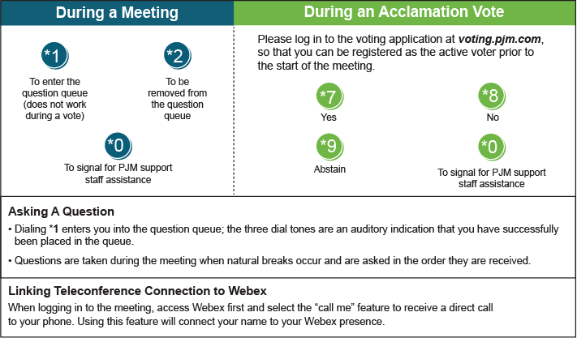

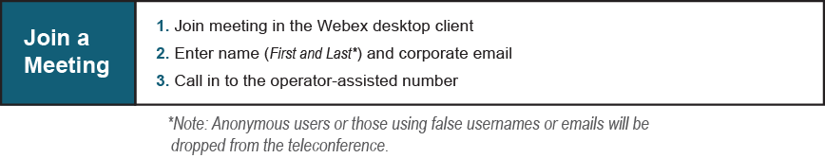
Provide feedback on the progress of this group: Facilitator Feedback Form
Visit learn.pjm.com, an easy-to-understand resource about the power industry and PJM’s role.

