Planning Committee
PJM Conference and Training Center
January 7, 2020
9:00 a.m. – 10:30 a.m. EPT

Administration (9:00-9:20)
- Welcome, announcements and review of the Anti-trust, Code of Conduct, and Media Participation Guidelines.
- Approve Planning Committee (PC) Agenda for this meeting
- Approve draft minutes from the December 12th, 2019 PC meeting
- Review of the 2020 PC Work Plan

Endorsements (9:20-9:30)
- Manual 14F Revisions
Mr. Jason Bilash, PJM, will present a second read to M14F regarding the removal of FERC 715 language from the proposal window. The Committee will be requested to endorse the revisions at today’s meeting.

First Reads (9:30-9:45)
- TO/TOP Matrix V14
Mr. Srinivas Kappagantula, PJM, will present the proposed changes to the TO/TOP Matrix. The Committee will be requested to provide a recommendation to the TOA-AC to approve the Draft TO/TOP Matrix V14 at the next meeting.

Informational Updates (9:45-10:30)
- FERC 845 Order
Ms. Susan McGill, PJM, will review the recent FERC 845 ruling.

- Critical Infrastructure Stakeholder Oversight
PJM will discuss next steps for the Critical Infrastructure Stakeholder Oversight Issue Charge.

- Designated Entity Design Standards
Mr. Jay Liu, PJM, will review the status of bi-annual (every two years) review of the Designated Entity Minimum Required Standards as required by the DEDSS Charter.
- Capacity Interconnection Rights Education
Mr. Jason Quevada, PJM, will provide follow up to data requests on the Capacity Interconnection Rights process.
- Reliability Compliance Update
Mr. Preston Walker, PJM, will provide an update on the activities, issues and items of interest at NERC, SERC, and RF.
- Model Build Activity Update
Mr. Peter Lamaina, PJM, will provide an update regarding current model build activities, including the 2020 series RTEP update and MOD-032 announcement.

Informational Posting

Future Meeting Dates
Tuesday, February 04, 2020 | 9:00 a.m. – 12:00 p.m. | Planning Committee | PJM Conference & Training Center/ WebEx
Tuesday, March 10, 2020 | 9:00 a.m. – 12:00 p.m. | Planning Committee | PJM Conference & Training Center/ WebEx
Tuesday, April 14, 2020 | 9:00 a.m. – 12:00 p.m. | Planning Committee | PJM Conference & Training Center/ WebEx
Tuesday, May 12, 2020 | 9:00 a.m. – 12:00 p.m. | Planning Committee | PJM Conference & Training Center/ WebEx
Tuesday, June 02, 2020 | 9:00 a.m. – 12:00 p.m. | Planning Committee | PJM Conference & Training Center/ WebEx
Tuesday, July 07, 2020 | 9:00 a.m. – 12:00 p.m. | Planning Committee | PJM Conference & Training Center/ WebEx
Tuesday, August 04, 2020 | 9:00 a.m. – 12:00 p.m. | Planning Committee | PJM Conference & Training Center/ WebEx
Tuesday, September 01, 2020 | 9:00 a.m. – 12:00 p.m. | Planning Committee | PJM Conference & Training Center/ WebEx
Tuesday, October 06, 2020 | 9:00 a.m. – 12:00 p.m. | Planning Committee | PJM Conference & Training Center/ WebEx
Wednesday, November 04, 2020 | 9:00 a.m. – 12:00 p.m. | Planning Committee | PJM Conference & Training Center/ WebEx
Tuesday, December 01, 2020 | 9:00 a.m. – 12:00 p.m. | Planning Committee | PJM Conference & Training Center/ WebEx
Author: Molly Mooney

Antitrust:
You may not discuss any topics that violate, or that might appear to violate, the antitrust laws including but not limited to agreements between or among competitors regarding prices, bid and offer practices, availability of service, product design, terms of sale, division of markets, allocation of customers or any other activity that might unreasonably restrain competition. If any of these items are discussed the chair will re-direct the conversation. If the conversation still persists, parties will be asked to leave the meeting or the meeting will be adjourned.

Code of Conduct:
As a mandatory condition of attendance at today's meeting, attendees agree to adhere to the PJM Code of Conduct as detailed in PJM Manual M-34 section 4.5, including, but not limited to, participants' responsibilities and rules regarding the dissemination of meeting discussion and materials.

Public Meetings/Media Participation:
Unless otherwise noted, PJM stakeholder meetings are open to the public and to members of the media. Members of the media are asked to announce their attendance at all PJM stakeholder meetings at the beginning of the meeting or at the point they join a meeting already in progress. Members of the Media are reminded that speakers at PJM meetings cannot be quoted without explicit permission from the speaker. PJM Members are reminded that "detailed transcriptional meeting notes" and white board notes from "brainstorming sessions" shall not be disseminated. Stakeholders are also not allowed to create audio, video or online recordings of PJM meetings. PJM may create audio, video or online recordings of stakeholder meetings for internal and training purposes, and your participation at such meetings indicates your consent to the same.
Participant Identification in WebEx:
When logging into the WebEx desktop client, please enter your real first and last name as well as a valid email address. Be sure to select the “call me” option.
PJM support staff continuously monitors WebEx connections during stakeholder meetings. Anonymous users or those using false usernames or emails will be dropped from the teleconference.

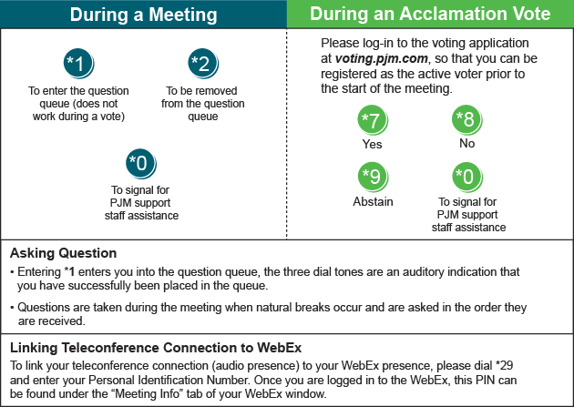

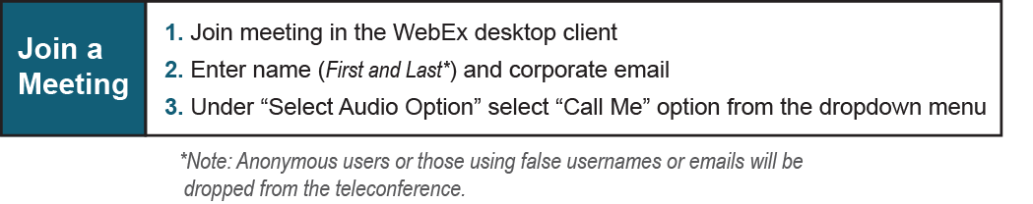

Provide feedback on the progress of this group: Facilitator Feedback Form
Visit learn.pjm.com, an easy-to-understand resource about the power industry and PJM’s role.

