May Planning Committee
Teleconference / WebEx
May 12, 2020
9:00 a.m. – 12:00 p.m. EPT

Administration (9:00-9:15)
- Welcome, announcements and review of the Anti-trust, Code of Conduct, and Media Participation Guidelines.
- Approve Planning Committee (PC) Agenda for this meeting
- Approve draft minutes from the April 14th, 2020 PC meeting

Endorsements (9:15-10:15)
- Storage as Transmission Asset
Mr. Jeff Goldberg, PJM, will present a second read of a problem statement/issue charge regarding storage as a transmission asset. The Committee will be requested to endorse the issue charge at today’s meeting.

- Market Efficiency Process Enhancement Task Force Update
Mr. Jack Thomas, PJM, will review the work completed at the Market Efficiency Process Enhancement Task Force. The Committee will be requested to vote on the packages at today’s meeting.

- Critical Infrastructure Stakeholder Oversight
- Mr. Robert Taylor, Exelon, will present a second read of a redline version of the Critical Infrastructure Stakeholder Oversight Issue Charge.

- Mr. Erik Heinle, Office of the People’s Council for the District of Colombia, will present an alternate to the redline version of the Critical Stakeholder Oversight Issue Charge.
The Committee will be requested to vote on the proposed revisions to the CISO issue charge at today’s meeting.

First Reads (10:15- 10:45)
- PMU Placement in RTEP Planning Process
Mr. Shaun Murphy, PJM, will review the Problem Statement, Issue Charge and proposed solution to address the need for PMU Placement in the RTEP planning process. The committee will be asked to approve the issue charge and endorse the proposed manual language as part of the Quick Fix process outlined in Section 8.6.1 of Manual 34 at the June PC meeting.

- 2020 RRS Assumptions
Mr. Jason Quevada, PJM, will present the 2020 RRS assumptions as developed in the Resource Adequacy Analysis Subcommittee. The committee will be requested to endorse the study assumptions at the June PC meeting.
- Manual 14A, E and G Changes
Ms. Onyinye Caven, PJM, will present changes to Manuals 14A, 14E and 14G identified as part of the periodic review. The committee will be requested to endorse the Manual changes at the June PC meeting.

Informational Updates (10:45 – 12:00)
- Exelon Transmission Planning Criteria Update
Mr. Thomas Leeming, Exelon, will provide an overview of the updated 715 criteria that applies to all the Exelon Operating Companies.

- AMP Transmission Planning Criteria Update
Mr. Ryan Dolan, AMP, will provide an overview of the updated 715 criteria that applies to all the AMP Operating Companies.

- Dominion Transmission Planning Criteria Update
Mr. Kyle Hannah, Dominion, will provide an overview of the updated 715 criteria that applies to all the Dominion Operating Companies.

- FERC Compliance Filing Update
Mr. Ray Fernandez, PJM, will discuss cost allocation issues associated with multiple orders from FERC that require resettlement.

- Transmission & Substation Subcommittee Update
Mr. Jay Liu, PJM, will provide an update on the TSS work activities through 2019 and the first half of 2020 and a work plan for the remainder of the year.

- Reliability Compliance Update
Mr. Mark Kuras, PJM, will provide an update on the activities, issues and items of interest at NERC, SERC, and RF.

- Load Forecast Update
Mr. Andrew Gledhill, PJM, will provide an update on estimated Covid-19 impacts on recent loads and discuss analysis shared with the Load Analysis Subcommittee.

- Critical Infrastructure Stakeholder Update
Ms. Christina Stotesbury, PJM, will discuss the work being done at the most recent Critical Infrastructure Stakeholder Oversight Special Planning Committee session.

Informational Posting
Model Build Activity Update
- The 2020 series RTEP Trial 3 powerflow cases and associated files are being reviewed by PJM staff and the Transmission Owners. The preliminary 5 year short circuit results have been provided to PJM’s Transmission Planning Department; they will reach out to Transmission Owners with any questions. PJM’s System Planning Modeling and Support Department will reach out about any potential baselines for the 2 year case.
- The 2019 series MMWG 2020 winter study case is being updated. There will be two Trials where Transmission Owners are able to provide updates. The final updates will be provided to PowerTech by PJM on May 22, 2020.
- For the 2020 series MMWG powerflow cases, Transmission Owners are able to submit updates to project files via Model on Demand, provide load and device profiles for all 12 cases and Tie Line updates to PJM by May 22, 2020.

MOD-032 Update
- Posted with materials for the May PC is a document describing 2020 MOD-032 updates. The Gen Model window will open May 1 and remain open through June 15. Generator Owners have the option of using data submitted in previous years to prepopulate the 2020 forms. Gen Model link: https://pjm.com/planning/services-requests/planning-modeling-submission-mod-032.aspx; for any questions or comments email MOD-032@pjm.com

PJM Interconnection Queue Status Update
PJM has posted slides showing an update on the status of the PJM Interconnection Queues.

Capacity Capability Senior Task Force Update
The Capacity Capability Senior Task Force charter was approved at the March 26 MRC in order to consider provisions to implement Effective Load Carrying Capability to calculate the capacity market capability of all Intermittent Resources (such as wind and solar) and limited duration resources (such as Energy Storage Resources). The group aims to complete a proposal in August for filing with FERC before October 30, consistent with a deadline FERC set in an April 10 order. PJM proposed design components at the second meeting on April 27, and the group will consider proposed solution options at the May 20 meeting.

Proposed Amendments to Attachment M-3 of the PJM Tariff
The Notice of Transmission Owners Consultation with the Members Committee Regarding Proposed Amendments to Attachment M-3 of the PJM Tariff is available on behalf of the PJM Transmission Owners has been posted with today’s meeting materials. Note that written comments on the Attachment M-3 Amendments may be submitted for consideration by email to: Comments_for_Transmission_Owners@pjm.com on or before June 8, 2020.

Future Meeting Dates
Thursday, May 21, 2020 | 9:00 a.m. – 12:00 p.m. | Special PC: Critical Infrastructure | WebEx
Tuesday, June 02, 2020 | 9:00 a.m. – 12:00 p.m. | Planning Committee | PJM Conference & Training Center/ WebEx
Friday, June 19, 2020 | 1:00 p.m. – 4:00 p.m. | Special PC: Critical Infrastructure | PJM Conference & Training Center/ WebEx
Tuesday, July 07, 2020 | 9:00 a.m. – 12:00 p.m. | Planning Committee | PJM Conference & Training Center/ WebEx
Tuesday, August 04, 2020 | 9:00 a.m. – 12:00 p.m. | Planning Committee | PJM Conference & Training Center/ WebEx
Tuesday, September 01, 2020 | 9:00 a.m. – 12:00 p.m. | Planning Committee | PJM Conference & Training Center/ WebEx
Tuesday, October 06, 2020 | 9:00 a.m. – 12:00 p.m. | Planning Committee | PJM Conference & Training Center/ WebEx
Wednesday, November 04, 2020 | 9:00 a.m. – 12:00 p.m. | Planning Committee | PJM Conference & Training Center/ WebEx
Tuesday, December 01, 2020 | 9:00 a.m. – 12:00 p.m. | Planning Committee | PJM Conference & Training Center/ WebEx
Author: Molly Mooney

Antitrust:
You may not discuss any topics that violate, or that might appear to violate, the antitrust laws including but not limited to agreements between or among competitors regarding prices, bid and offer practices, availability of service, product design, terms of sale, division of markets, allocation of customers or any other activity that might unreasonably restrain competition. If any of these items are discussed the chair will re-direct the conversation. If the conversation still persists, parties will be asked to leave the meeting or the meeting will be adjourned.
Code of Conduct:
As a mandatory condition of attendance at today's meeting, attendees agree to adhere to the PJM Code of Conduct as detailed in PJM Manual M-34 section 4.5, including, but not limited to, participants' responsibilities and rules regarding the dissemination of meeting discussion and materials.

Public Meetings/Media Participation:
Unless otherwise noted, PJM stakeholder meetings are open to the public and to members of the media. Members of the media are asked to announce their attendance at all PJM stakeholder meetings at the beginning of the meeting or at the point they join a meeting already in progress. Members of the Media are reminded that speakers at PJM meetings cannot be quoted without explicit permission from the speaker. PJM Members are reminded that "detailed transcriptional meeting notes" and white board notes from "brainstorming sessions" shall not be disseminated. Stakeholders are also not allowed to create audio, video or online recordings of PJM meetings. PJM may create audio, video or online recordings of stakeholder meetings for internal and training purposes, and your participation at such meetings indicates your consent to the same.
Participant Identification in WebEx:
When logging into the WebEx desktop client, please enter your real first and last name as well as a valid email address. Be sure to select the “call me” option.
PJM support staff continuously monitors WebEx connections during stakeholder meetings. Anonymous users or those using false usernames or emails will be dropped from the teleconference.

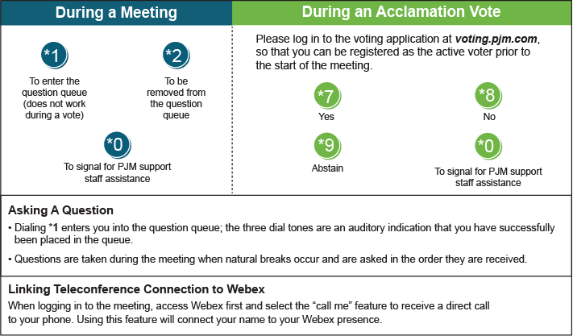

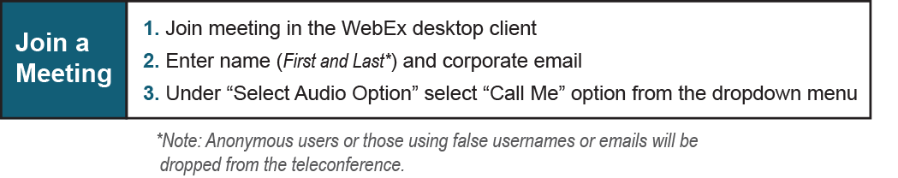

Provide feedback on the progress of this group: Facilitator Feedback Form
Visit learn.pjm.com, an easy-to-understand resource about the power industry and PJM’s role.

