June Planning Committee
Teleconference / WebEx
June 2, 2020
9:00 a.m. – 12:00 p.m. EPT

Administration (9:00-9:15)
- Welcome, announcements and review of the Anti-trust, Code of Conduct, and Media Participation Guidelines.
- Approve Planning Committee (PC) Agenda for this meeting
- Approve draft minutes from the May 12th, 2020 PC meeting

Endorsements (9:15 – 10:15)
- Manual 14A, E and G Changes
Onyinye Caven, PJM, will present changes to Manuals 14A, 14E and 14G identified as part of the periodic review. The committee will be requested to endorse the Manual changes at today’s meeting.
- 2020 RRS Assumptions
Jason Quevada, PJM, will present the 2020 RRS assumptions as developed in the Resource Adequacy Analysis Subcommittee. The committee will be requested to endorse the study assumptions at today’s meeting.
- PMU Placement in RTEP Planning Process
Shaun Murphy, PJM, will review the Problem Statement, Issue Charge and proposed solution to address the need for PMU Placement in the RTEP planning process. The committee will be asked to approve the issue charge and endorse the proposed revisions to Manual 14B: PJM Region Transmission Planning Process as part of the Quick Fix process outlined in Section 8.6.1 of Manual 34 at today’s meeting.

First Reads ( )

Informational Updates (10:15 – 11:30)
- Load Impact and Forecast Update
Andrew Gledhill, PJM, will present the estimated Covid-19 impacts on recent loads and an updated forecast to be used in the DY 2021/22 2nd IA pending FERC approval of waiver filed by PJM.

- FERC Compliance Filing Update
Ray Fernandez, PJM, will discuss cost allocation issues associated with multiple orders from FERC that require resettlement.

- FERC Order 845 Update
Pauline Foley, PJM, will provide an update on the FERC’s May 21, 2020 Order regarding PJM’s proposed tariff revisions filed on February 21, 2020 in compliance with the requirements of Order Nos. 845 and 845-A and the Commission’s December 19, 2019 Order.

- Competitive Planner Update
Ilyana Dropkin, PJM, will provide an update on the Competitive Planner application, a new web-based form or application that is developed for Transmission Owners and Developers to participate in the PJM competitive planning process.

- Critical Infrastructure Stakeholder Update
Christina Stotesbury, PJM, will discuss the work being done at the most recent Critical Infrastructure Stakeholder Oversight Special Planning Committee session.
Issue Tracking: Critical Infrastructure Stakeholder Oversight

Informational Posting
Model Build Activity Update
- The final 2019 series MMWG 2020 winter study case will be posted by Powertech on May 27, 2020.
- For the 2020 series MMWG powerflow cases, Transmission Owners are able to submit updates to project files via Model on Demand, provide load and device profiles for all 12 cases and Tie Line updates to PJM by May 29, 2020. PJM will submit the Trial 1 cases to Powertech by June 26, 2020.

Capacity Capability Senior Task Force Update
At the May 20 CCSTF, PJM solicited feedback on definitions for the design components introduced at the April 27 meeting and stakeholders offered additional design components. Energy Storage Association (ESA) provided solution options for the design components established at the April 27 meeting. PJM also presented a few solution options for stakeholder consideration. Stakeholders are asked to bring additional solution options to the June 4 meeting. The group will discuss proposed packages at the June 22 meeting, and it also aims to poll on an array of solution options in June. August 7 is the planned date to vote on packages in order to meet a FERC filing deadline of October 30. An updated Work Plan can be found on the CCSTF page on pjm.com.
Storage As Transmission Asset
Meeting dates have been set for the Special PC sessions for Storage As Transmission Asset shown below.
Issue Tracking: Storage As a Transmssion Asset

Proposed Amendments to Attachment M-3 of the PJM Tariff
The Notice of Transmission Owners Consultation with the Members Committee Regarding Proposed Amendments to Attachment M-3 of the PJM Tariff is available on behalf of the PJM Transmission Owners has been posted with the May 12, 2020 meeting materials. Note that written comments on the Attachment M-3 Amendments may be submitted for consideration by email to: Comments_for_Transmission_Owners@pjm.com on or before June 8, 2020.

Future Meeting Dates
Friday, June 05, 2020 | 1:00 p.m. – 4:00 p.m. | Special PC: Storage As a Transmission Asset | WebEx
Friday, June 19, 2020 | 1:00 p.m. – 4:00 p.m. | Special PC: Critical Infrastructure | WebEx
Monday, July 06, 2020 | 1:00 p.m. – 4:00 p.m. | Special PC: Storage As a Transmission Asset | WebEx
Tuesday, July 07, 2020 | 9:00 a.m. – 12:00 p.m. | Planning Committee | PJM Conference & Training Center/ WebEx
Friday, July 17, 2020 | 1:00 p.m. – 3:00 p.m. | Special PC: Critical Infrastructure | PJM Conference & Training Center/ WebEx
Tuesday, August 04, 2020 | 9:00 a.m. – 12:00 p.m. | Planning Committee | PJM Conference & Training Center/ WebEx
Thursday, August 06, 2020 | 1:00 p.m. – 4:00 p.m. | Special PC: Storage As a Transmission Asset | PJM Conference & Training Center/ WebEx
Friday, August 14, 2020 | 1:00 p.m. – 3:00 p.m. | Special PC: Critical Infrastructure | PJM Conference & Training Center/ WebEx
Monday, August 17, 2020 | 1:00 p.m. – 3:00 p.m. | Special PC: Pre Queue Education Session | WebEx
Monday, August 24, 2020 | 1:00 p.m. – 4:00 p.m. | Special PC: Storage As a Transmission Asset | PJM Conference & Training Center/ WebEx
Tuesday, September 01, 2020 | 9:00 a.m. – 12:00 p.m. | Planning Committee | PJM Conference & Training Center/ WebEx
Tuesday, September 22, 2020 | 9:00 a.m. – 12:00 p.m. | Special PC: Critical Infrastructure | PJM Conference & Training Center/ WebEx
Tuesday, September 22, 2020 | 1:00 p.m. – 3:00 p.m. | Special PC: Post ISA Education Session | WebEx
Friday, September 25, 2020 | 9:00 a.m. – 12:00 p.m. | Special PC: Storage As a Transmission Asset | PJM Conference & Training Center/ WebEx
Tuesday, October 06, 2020 | 9:00 a.m. – 12:00 p.m. | Planning Committee | PJM Conference & Training Center/ WebEx
Thursday, October 22, 2020 | 1:00 p.m. – 4:00 p.m. | Special PC: Storage As a Transmission Asset | PJM Conference & Training Center/ WebEx
Wednesday, November 04, 2020 | 9:00 a.m. – 12:00 p.m. | Planning Committee | PJM Conference & Training Center/ WebEx
Tuesday, December 01, 2020 | 9:00 a.m. – 12:00 p.m. | Planning Committee | PJM Conference & Training Center/ WebEx
Author: Molly Mooney

Antitrust:
You may not discuss any topics that violate, or that might appear to violate, the antitrust laws including but not limited to agreements between or among competitors regarding prices, bid and offer practices, availability of service, product design, terms of sale, division of markets, allocation of customers or any other activity that might unreasonably restrain competition. If any of these items are discussed the chair will re-direct the conversation. If the conversation still persists, parties will be asked to leave the meeting or the meeting will be adjourned.
Code of Conduct:
As a mandatory condition of attendance at today's meeting, attendees agree to adhere to the PJM Code of Conduct as detailed in PJM Manual M-34 section 4.5, including, but not limited to, participants' responsibilities and rules regarding the dissemination of meeting discussion and materials.

Public Meetings/Media Participation:
Unless otherwise noted, PJM stakeholder meetings are open to the public and to members of the media. Members of the media are asked to announce their attendance at all PJM stakeholder meetings at the beginning of the meeting or at the point they join a meeting already in progress. Members of the Media are reminded that speakers at PJM meetings cannot be quoted without explicit permission from the speaker. PJM Members are reminded that "detailed transcriptional meeting notes" and white board notes from "brainstorming sessions" shall not be disseminated. Stakeholders are also not allowed to create audio, video or online recordings of PJM meetings. PJM may create audio, video or online recordings of stakeholder meetings for internal and training purposes, and your participation at such meetings indicates your consent to the same.
Participant Identification in WebEx:
When logging into the WebEx desktop client, please enter your real first and last name as well as a valid email address. Be sure to select the “call me” option.
PJM support staff continuously monitors WebEx connections during stakeholder meetings. Anonymous users or those using false usernames or emails will be dropped from the teleconference.

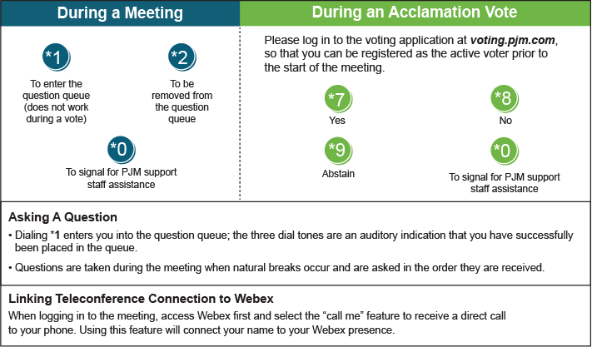

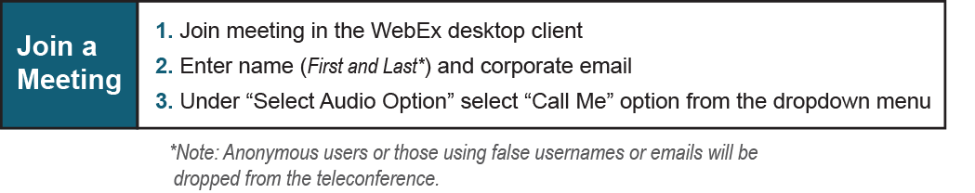

Provide feedback on the progress of this group: Facilitator Feedback Form
Visit learn.pjm.com, an easy-to-understand resource about the power industry and PJM’s role.

