August Planning Committee
Teleconference / WebEx
August 4, 2020
9:00 a.m. – 11:00 a.m. EPT

Administration (9:00 – 9:15)
- Welcome, announcements and review of the Anti-trust, Code of Conduct, and Media Participation Guidelines.
- Approve Planning Committee (PC) Agenda for this meeting
- Approve draft minutes from the July 7th, 2020 PC meeting

Endorsements (9:15 – 9:45)
- Load Model Selection
Patricio Rocha-Garrido, PJM, will present the results of the Load Model selection process for the 2020 Reserve Requirement Study. The committee will be requested to endorse this Load Model selection at today’s meeting.
- Manual 14A, B and G Changes
Onyinye Caven, PJM, will present changes to Manuals 14A, 14B and 14G in relation to the FERC’s Order on PJM’s Order 845 Second Compliance Filing. The committee will be requested to endorse the Manual changes at today’s meeting.

First Reads ( )
- Manual 14C Update
Mark Sims, PJM, will provide a first read of changes to Manual 14C: Generation and Transmission Interconnection Facility Construction, to enhance the cost and status tracking language for baseline and supplemental projects

Informational Updates (9:45 – 11:00)
- State Agreement Approach
Mark Sims, PJM, will provide an informational discussion on the PJM State Agreement Approach.
- Recent Load Impacts
Andrew Gledhill, PJM, will present the estimated Covid-19 impacts on recent loads.
- Interconnection Study Statistics
Susan McGill, PJM, will present the interconnection study statistics for the first half of 2020, as required under Order 845.
- FERC Update - Compliance Filing Ordered in Docket No. EL19-91-000
Pauline Foley, PJM, will discuss the Commission’s June 18, 2020 Order in Docket No. EL19-91-000 regarding immediate-need reliability exemptions, including the compliance directives.
- Critical Infrastructure Stakeholder Update
Joe Hay, PJM, will discuss the work being done at the most recent Critical Infrastructure Stakeholder Oversight Special Planning Committee sessions.
Issue Tracking: Critical Infrastructure Stakeholder Oversight
- Storage As Transmission Asset Update
Michele Greening, PJM will discuss work being done at the most recent Storage As Transmission Asset Special Planning Committee sessions.
Issue Tracking: Storage As a Transmssion Asset

Informational Posting
Model Build Activity Update
2020 Series MMWG
- Powerflow – The 2020 series MMWG Trial 1 case updates were submitted to Powertech on Friday July 31, 2020; Powertech will provide Trial 2 cases by Friday August 7, 2020; the Transmission Owners will submit updates for the Trial 2 cases by Friday August 14, 2020; PJM will submit Trial 2 updates to Powertech by Friday August 21, 2020; Powertech will provide Trial 3 cases by Friday August 28, 2020.
2021 Series RTEP
- Powerflow – PJM will send the Trial 0 seedcase to the Transmission Owners by Tuesday August 25, 2020
- Short Circuit – PJM will send the Master Tie Line workbook to the Transmission Owners by Friday August 7, 2020; the Transmission Owners will provide updates by Friday August 21, 2020; PJM will send the Trial 0 case to the Transmission Owners by Friday September 4, 2020
2020 Work Plan
The Planning Committee 2020 work plan with additional granularity to end dates is posted with today’s materials.

Future Meeting Dates
Thursday, August 06, 2020 | 1:00 p.m. – 4:00 p.m. | Special PC: Storage As a Transmission Asset | WebEx
Friday, August 14, 2020 | 1:00 p.m. – 3:00 p.m. | Special PC: Critical Infrastructure | WebEx
Monday, August 17, 2020 | 1:00 p.m. – 3:00 p.m. | Special PC: Pre Queue Education Session | WebEx
Monday, August 24, 2020 | 1:00 p.m. – 4:00 p.m. | Special PC: Storage As a Transmission Asset | WebEx
Tuesday, September 01, 2020 | 9:00 a.m. – 12:00 p.m. | Planning Committee | WebEx
Tuesday, September 22, 2020 | 9:00 a.m. – 12:00 p.m. | Special PC: Critical Infrastructure | WebEx
Tuesday, September 22, 2020 | 1:00 p.m. – 3:00 p.m. | Special PC: Post ISA Education Session | WebEx
Friday, September 25, 2020 | 9:00 a.m. – 12:00 p.m. | Special PC: Storage As a Transmission Asset | WebEx
Tuesday, October 06, 2020 | 9:00 a.m. – 12:00 p.m. | Planning Committee | PJM Conference & Training Center/ WebEx
Thursday, October 22, 2020 | 1:00 p.m. – 4:00 p.m. | Special PC: Storage As a Transmission Asset | PJM Conference & Training Center/ WebEx
Wednesday, November 04, 2020 | 9:00 a.m. – 12:00 p.m. | Planning Committee | PJM Conference & Training Center/ WebEx
Tuesday, December 01, 2020 | 9:00 a.m. – 12:00 p.m. | Planning Committee | PJM Conference & Training Center/ WebEx
Author: Molly Mooney

Antitrust:
You may not discuss any topics that violate, or that might appear to violate, the antitrust laws including but not limited to agreements between or among competitors regarding prices, bid and offer practices, availability of service, product design, terms of sale, division of markets, allocation of customers or any other activity that might unreasonably restrain competition. If any of these items are discussed the chair will re-direct the conversation. If the conversation still persists, parties will be asked to leave the meeting or the meeting will be adjourned.

Code of Conduct:
As a mandatory condition of attendance at today's meeting, attendees agree to adhere to the PJM Code of Conduct as detailed in PJM Manual M-34 section 4.5, including, but not limited to, participants' responsibilities and rules regarding the dissemination of meeting discussion and materials.

Public Meetings/Media Participation:
Unless otherwise noted, PJM stakeholder meetings are open to the public and to members of the media. Members of the media are asked to announce their attendance at all PJM stakeholder meetings at the beginning of the meeting or at the point they join a meeting already in progress. Members of the Media are reminded that speakers at PJM meetings cannot be quoted without explicit permission from the speaker. PJM Members are reminded that "detailed transcriptional meeting notes" and white board notes from "brainstorming sessions" shall not be disseminated. Stakeholders are also not allowed to create audio, video or online recordings of PJM meetings. PJM may create audio, video or online recordings of stakeholder meetings for internal and training purposes, and your participation at such meetings indicates your consent to the same.
Participant Identification in WebEx:
When logging into the WebEx desktop client, please enter your real first and last name as well as a valid email address. Be sure to select the “call me” option.
PJM support staff continuously monitors WebEx connections during stakeholder meetings. Anonymous users or those using false usernames or emails will be dropped from the teleconference.

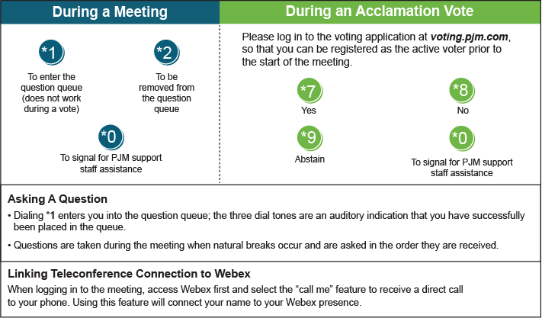

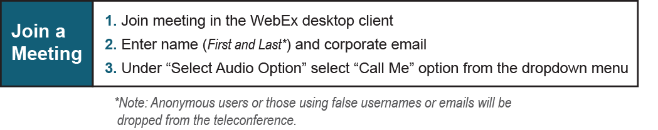

Provide feedback on the progress of this group: Facilitator Feedback Form
Visit learn.pjm.com, an easy-to-understand resource about the power industry and PJM’s role.

