Risk Management Committee

Webex

August 23, 2022

1:00 p.m. – 4:00 p.m. EPT

[Updated]

Administration (1:00-1:10)

Jim Gluck and Christina Stotesbury, PJM, will provide a welcome, announcements, and review the Antitrust, Code of Conduct, Public Meetings/Media Participation, and the Webex Participant Identification Requirements.

The Committee will be asked to approve the draft minutes from the July 26, 2022 Risk Management Committee meeting.

1. Chrissy Stotesbury, PJM, will review the Risk Management Committee work plan.

Informational Updates (1:10-1:50)

1. FERC Updates (1:10-1:30)
   1. Colleen Hicks, PJM, will review the recent FERC Order related to PJM’s FTR Credit Requirement (ER22-2029-000, EL22-32-000) and next steps.
   2. Colleen Hicks, PJM, will provide an update on the FERC NOPR’s related to Duty of Candor (RM22-20-000) and Credit Related Information Sharing in Organized Wholesale Electric Markets (RM22-13-000).
   3. Colleen Hicks, PJM, will provide an update on the Order to Show Cause related to the use of Mark to Auction and Volumetric Minimums for FTR Collateral in certain RTO/ISO’s (EL22-62-000, EL22-63-000, EL22-64-000, EL22-65-000).

HSIM Implementation Update (1:30-1:50)

James Waweru and Gwen Kelly, PJM, will provide an update on the HSIM implementation.

First Reads (1:50 – 2:20)

FTR Bilateral Review and Reporting Requirements – Matrix (1:50-2:10)

Jim Gluck, PJM, will review the solution packages to address the FTR Bilateral Review and Reporting issue. The committee will be asked to endorse a solution at its next meeting.

[Issue Tracking: FTR Bilateral Review and Reporting Requirements](https://pjm.com/committees-and-groups/issue-tracking/issue-tracking-details.aspx?Issue=b2c1be66-9571-4332-b5b0-7984d40d67a0)

Working Items (2:10-3:20)

1. Peak Market Activity Credit Requirement – Matrix (2:10-2:50)

Jim Gluck, PJM, will review matrix interests, design components, status quo, and design options. All participants are encouraged to provide their input.

[Issue Tracking: Peak Market Activity Credit Requirement](https://www.pjm.com/committees-and-groups/issue-tracking/issue-tracking-details.aspx?Issue=94cf6d7f-df09-4965-aa57-8108f42df9b9)

1. Yong Hu, PJM, will review an example of the proposed PMA calculation and timeline.

Market Participant Default Flexibility – Matrix (2:50-3:10)

Jim Gluck, PJM, will facilitate a continued discussion on solution options and solution packages. All participants are encouraged to provide their input.

[Issue Tracking: Market Participant Default Flexibility](https://pjm.com/committees-and-groups/issue-tracking/issue-tracking-details.aspx?Issue=bd8348bc-f0e2-4c19-8db9-0156f62c6846)

FTR Residual Credit Risk – Survey Results (3:10-3:20)

Jim Gluck, PJM, will review results of the poll sent to the RMC on July 28.

[Issue Tracking: FTR Market Residual Risk Management](https://www.pjm.com/committees-and-groups/issue-tracking/issue-tracking-details.aspx?Issue=6a26a4e2-bed9-4d2f-84ef-166fd963eaee)

Additional Items (3:20-3:40)

1. Key Risk Metrics (3:20-3:30)

Gwen Kelly, PJM, will review key risk metrics for the committee’s consideration and feedback.

1. GreenHat Update (3:30-3:40)

Chris O’Hara, PJM, and Mark Stanisz, PJM, will provide an update on the August 19, 2022 FERC orders approving stipulations and consent agreements that resolve claims arising from the GreenHat FTR default (Docket No. IN18-9-000).

Informational Section

Energy Price Formation Senior Task Force (EPFSTF)

Meeting materials and upcoming meeting dates are available on the [EPFSTF website](https://pjm.com/committees-and-groups/task-forces/epfstf). Discussions involving risk may occur at the EPFSTF.

Operating Committee Special Session – Outage Coordination

Meeting materials and upcoming meeting dates are available on the [OC website](https://www.pjm.com/committees-and-groups/committees/oc).

Bankruptcy Protections

Information related to bankruptcy protections solution package has been posted with the July RMC materials. The solution package will be first read at the August Markets and Reliability Committee (MRC).

[Issue Tracking: Bankruptcy Protections](https://pjm.com/committees-and-groups/issue-tracking/issue-tracking-details.aspx?Issue=686f7356-146b-4fa8-8417-7ba0f8e9ba7c)

|  |
| --- |
| **Future Topics** |
|  |

|  |  |  |  |  |  |
| --- | --- | --- | --- | --- | --- |
| **Future Meeting Dates and Materials** | | | | **Materials Due  to Secretary** | **Materials Published** |
| Date | Time | Location |  | |  |
| September 20, 2022 | 1:00 p.m. | PJM Conference & Training Center/Webex | September 8, 2022 | | September 13, 2022 |
| October 19, 2022 | 1:00 p.m. | PJM Conference & Training Center/Webex | October 7, 2022 | | October 12, 2022 |
| November 15, 2022 | 1:00 p.m. | PJM Conference & Training Center/Webex | November 3, 2022 | | November 8, 2022 |
| December 20, 2022 | 1:00 p.m. | PJM Conference & Training Center/Webex | December 8, 2022 | | December 13, 2022 |

Author: Christina Stotesbury

Antitrust:

You may not discuss any topics that violate, or that might appear to violate, the antitrust laws including but not limited to agreements between or among competitors regarding prices, bid and offer practices, availability of service, product design, terms of sale, division of markets, allocation of customers or any other activity that might unreasonably restrain competition. If any of these items are discussed the chair will re-direct the conversation. If the conversation still persists, parties will be asked to leave the meeting or the meeting will be adjourned.

Code of Conduct:

As a mandatory condition of attendance at today's meeting, attendees agree to adhere to the PJM Code of Conduct as detailed in PJM Manual M-34 section 4.5, including, but not limited to, participants' responsibilities and rules regarding the dissemination of meeting discussion and materials.

Public Meetings/Media Participation:

Unless otherwise noted, PJM stakeholder meetings are open to the public and to members of the media. Members of the media are asked to announce their attendance at all PJM stakeholder meetings at the beginning of the meeting or at the point they join a meeting already in progress. Members of the Media are reminded that speakers at PJM meetings cannot be quoted without explicit permission from the speaker. PJM Members are reminded that "detailed transcriptional meeting notes" and white board notes from "brainstorming sessions" shall not be disseminated. Stakeholders are also not allowed to create audio, video or online recordings of PJM meetings. PJM may create audio, video or online recordings of stakeholder meetings for internal and training purposes, and your participation at such meetings indicates your consent to the same.

Participant Identification in Webex:

When logging into the Webex desktop client, please enter your real first and last name as well as a valid email address. Be sure to select the “call me” option.

PJM support staff continuously monitors Webex connections during stakeholder meetings. Anonymous users or those using false usernames or emails will be dropped from the teleconference.

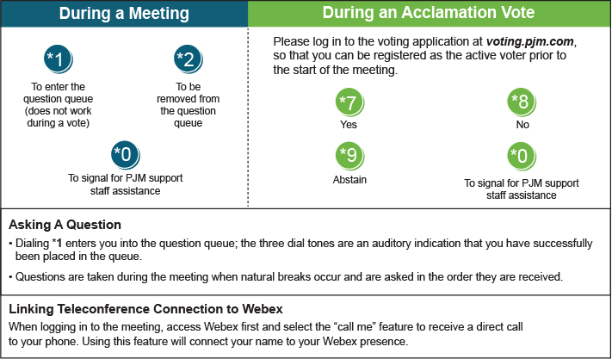

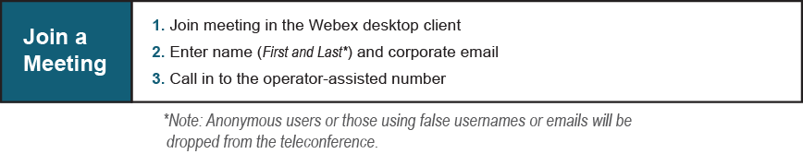

Provide feedback on the progress of this group: [*Facilitator Feedback Form*](https://www.pjm.com/committees-and-groups/committees/form-facilitator-feedback.aspx)   
Visit [*learn.pjm.com*](https://learn.pjm.com/), an easy-to-understand resource about the power industry and PJM’s role.