Credit Subcommittee
Conference Call
July 7, 2015
1:30 p.m. – 3:30 p.m. EST

Administration (1:30-1:40)
The Secretary will take roll call of all participants for the meeting.
PJM will ask for comments and or questions on the April 24, 2015 CS meeting minutes.
Members are requested to adhere to the Anti-Trust Policy, Code of Conduct, and Public Meetings/Media Participation guidelines listed below.

Working Issues (1:40-2:40)
- RPM Update: Capacity Performance (1:40 – 2:10)
Laura Walter, PJM, will review credit changes due to the approved Capacity Performance filing issued June 9, 2015 (Dockets ER15-623-000, EL15-29-000, ER15-623-001, and EL15-41-000).
- Peak Market Activity (2:10 – 2:40)
Hal Loomis, PJM, will present the analysis performed to date on historical credit exposure.

Future Agenda Items (2:40 – 2:50)
- Increment Bid and Decrement Offer Credit Requirement
Members have requested that the INC/DEC credit requirement remain on the agenda.
- Financial Transmission Rights Undiversified Credit Requirement
Issue Tracking: FTR Undiversified Credit Requirement
- Attachment Q: Wording Cleanup
Members are welcome to request additional discussion items at this or any future meeting.

Future Meeting Dates
August 5, 2015 | 1:30 p.m. – 3:30 p.m. EST | Conference Call

Anti-trust:
You may not discuss any topics that violate, or that might appear to violate, the antitrust laws including but not limited to agreements between or among competitors regarding prices, bid and offer practices, availability of service, product design, terms of sale, division of markets, allocation of customers or any other activity that might unreasonably restrain competition. If any of these items are discussed the chair will re-direct the conversation. If the conversation still persists, parties will be asked to leave the meeting or the meeting will be adjourned.

Code of Conduct:
As a mandatory condition of attendance at today's meeting, attendees agree to adhere to the PJM Code of Conduct as detailed in PJM Manual M-34 section 4.5, including, but not limited to, participants' responsibilities and rules regarding the dissemination of meeting discussion and materials.

Public Meetings/Media Participation:
Unless otherwise noted, PJM stakeholder meetings are open to the public and to members of the media. Members of the media are asked to announce their attendance at all PJM stakeholder meetings at the beginning of the meeting or at the point they join a meeting already in progress. Members of the Media are reminded that speakers at PJM meetings cannot be quoted without explicit permission from the speaker. PJM Members are reminded that "detailed transcriptional meeting notes" and white board notes from "brainstorming sessions" shall not be disseminated. Stakeholders are also not allowed to create audio, video or online recordings of PJM meetings.

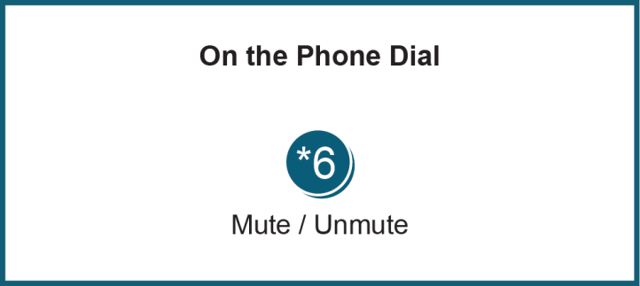

Author: Laura Walter

