DER and Inverter-based Resources Subcommittee – EDC Coordination Workshop
WebEx Only
September 21, 2021
3:00 p.m. – 5:00 p.m. ET

Administration (3:00 – 3:05)
Scott Baker, chair, will open the meeting and review the agenda.
Hamad Ahmed, secretary, will review the meeting participation guidelines.

Order 2222 – Feedback on PJM Staff Proposal on DER Aggregation from the utilities (3:05 – 4:55)
PJM will present and stakeholders will discuss an updated version of the operational coordination framework between RTO, market participant, and distribution utility.
Sue Glatz, PJM, will review its proposal to ensure that DER participating in a DERA are accounted for in the PJM transmission planning model and stakeholders will discuss.

Action items and next meeting agenda (4:55 – 5:00)
- The facilitation team will review action items from the meeting and take requests for future agenda items.
Future Meeting Dates and Materials |  |  | Materials Due  to Secretary | Materials Published
Date | Time | Location | 5 p.m. | 4 p.m.
September 24, 2021 | 9:00 – 4:00 | WebEx | September 16, 2021 | September 21, 2021
October 22, 2021 | 9:00 – 4:00 | WebEx | October 14, 2021 | October 19, 2021
November 9, 2021-EDC Coordination workshop | 3:00 – 5:00 | WebEx | November 1, 2021 | November 4, 2021
November 22, 2021 | 9:00 – 3:00 | WebEx | November 12, 2021 | November 17, 2021
December 9, 2021-EDC Coordination workshop | 3:00 – 5:00 | WebEx | December 1, 2021 | December 6, 2021
December 21, 2021 | 9:00 – 4:00 | WebEx | December 13, 2021 | December 16, 2021

Author: Hamad Ahmed

Antitrust:
You may not discuss any topics that violate, or that might appear to violate, the antitrust laws including but not limited to agreements between or among competitors regarding prices, bid and offer practices, availability of service, product design, terms of sale, division of markets, allocation of customers or any other activity that might unreasonably restrain competition. If any of these items are discussed the chair will re-direct the conversation. If the conversation still persists, parties will be asked to leave the meeting or the meeting will be adjourned.

Code of Conduct:
As a mandatory condition of attendance at today's meeting, attendees agree to adhere to the PJM Code of Conduct as detailed in PJM Manual M-34 section 4.5, including, but not limited to, participants' responsibilities and rules regarding the dissemination of meeting discussion and materials.

Public Meetings/Media Participation:
Unless otherwise noted, PJM stakeholder meetings are open to the public and to members of the media. Members of the media are asked to announce their attendance at all PJM stakeholder meetings at the beginning of the meeting or at the point they join a meeting already in progress. Members of the Media are reminded that speakers at PJM meetings cannot be quoted without explicit permission from the speaker. PJM Members are reminded that "detailed transcriptional meeting notes" and white board notes from "brainstorming sessions" shall not be disseminated. Stakeholders are also not allowed to create audio, video or online recordings of PJM meetings. PJM may create audio, video or online recordings of stakeholder meetings for internal and training purposes, and your participation at such meetings indicates your consent to the same.
Participant Identification in Webex:
When logging into the Webex desktop client, please enter your real first and last name as well as a valid email address. Be sure to select the “call me” option.
PJM support staff continuously monitors Webex connections during stakeholder meetings. Anonymous users or those using false usernames or emails will be dropped from the teleconference.



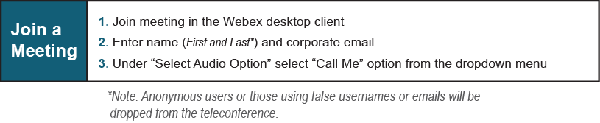

Provide feedback on the progress of this group: Facilitator Feedback Form
Visit learn.pjm.com, an easy-to-understand resource about the power industry and PJM’s role.

